**SINCERE THANKS**

I would like to sincerely thank the Faculty of Information Technology, Dai Duy Tan University for creating favorable conditions for me to carry out this topic. I would like to sincerely thank Mr. Nguyen Minh Nhat, who has guided and helped me throughout the time of carrying out the topic. During the process of carrying out the topic, he has enthusiastically guided and discussed with me to help me solve problems to complete the topic. I would also like to express my deep gratitude to the teachers in the faculty who have enthusiastically taught and equipped me with extremely valuable knowledge in the past school years. My father, mother, brothers and sisters have cared for, looked after and encouraged me. My friends have supported and helped us in difficult times as well as during the time of studying and researching. Although I have tried to complete the thesis within the allowed scope and ability, there will certainly be shortcomings, I respectfully ask for sympathy and guidance from teachers and friends.

Da Nang, April 18, 2025.

Performed by student

Le Thai Trung

**COMMITMENT**

I hereby commit that:

1. The contents of this thesis are done by me under the direct guidance of Mr. Nguyen Minh Nhat.
2. All references used in the thesis are clearly and honestly cited with the name of the author, name of the work, time and place of publication.
3. Any illegal copying, violation of training regulations, or fraud, I will take full responsibility.

Da Nang, April 18, 2025.

Performed by student

Le Thai Trung

**OPENING**

**1.** **Reason for choosing the topic:**

Governments and environmental agencies require continuous, high‑resolution data to enforce standards, assess pollution sources, and trigger timely public‑health advisories. Traditional monitoring stations are accurate but sparse and expensive; customers told us they need a distributed network of low‑cost sensors whose data is automatically validated and aggregated so that no “hot spot” goes unnoticed.

Meanwhile, urban planners, schools and hospitals want predictive insights—forecasts of pollutant spikes that let them adjust traffic flows, outdoor activities or ventilation schedules before air becomes unhealthy. They’ve asked for easy integration (APIs, dashboard widgets) into existing management platforms, mobile alerts for threshold breaches, and a user‑friendly web app for non‑technical staff.

Finally, community organizations and citizens need transparency: open data access, clear visualizations and localized alerts. By building an end‑to‑end system—sensor layer, AI‑driven anomaly detection and forecasting, plus customizable dashboards—we satisfy all these real‑world requirements, ensuring our solution isn’t just technically innovative, but truly useful to its customers.

Facing the need to view air quality on the internet as well as being passionate about web application programming. I chose the topic: "AI-powered air quality monitoring system" as the topic of my thesis.

**2.** **Purpose and meaning of the topic:**

**a. Purpose:**

• Develop a low‑cost, distributed sensor network with automated data‐validation and calibration;  
• Apply machine‑learning models to detect anomalies and predict pollutant trends hours in advance;  
• Expose clean, standardized data through APIs and integrate seamlessly with third‑party management systems;  
• Provide an intuitive web and mobile dashboard with customizable alerts and visualizations;  
• And validate system performance against reference stations to ensure reliability.

**b. Meaning:**

On the Theoretical Meaning:

* Advances research on applying AI and IoT in real-time environmental monitoring.
* Provides a foundation for developing smart, data-driven forecasting models.

On the Practical Meaning:

* Delivers a scalable, low-cost system for real-time air quality tracking and alerts.
* Supports timely decision-making and raises public health awareness.

**3.** **Object and scope of research:**

**a. Object:**

The system is designed for government environmental agencies, local authorities, schools, hospitals, urban planners, and the general public—anyone who needs real-time, reliable air quality information for decision-making, health protection, or public awareness.

**b. Scope:**

Responding to customer requirements for web development must:

* Deploy and calibrate low-cost air quality sensors.
* Collect, clean, and validate real-time environmental data.
* Apply AI models for anomaly detection and forecasting.
* Develop a web/mobile dashboard for data visualization and alerts.
* Integrate system components and validate overall performance.

**4. Research methods:**

* Review literature on AI and IoT in air quality monitoring.
* Design and deploy low-cost sensors for real-time data collection.
* Develop a data pipeline and train machine learning models for forecasting.
* Build and test a web/mobile dashboard for user interaction.
* Gather expert feedback during development.
* Observe the operations and features of similar existing platforms.

**5. Expected outcome:**

The expected outcome is to complete the system and documentation by May 2025.

**6. Topic layout:**

The content of this thesis includes the following parts:  
Part 1: An overview of the topic and related technologies.  
Part 2: Analysis and design of the “AI-powered air quality monitoring system.”  
Part 3: Implementation, deployment, and testing of several customer requirements.  
 Although I have made great efforts to carry out this thesis, due to limited time and capability, shortcomings are inevitable. I sincerely hope for your understanding. The feedback from teachers is a valuable lesson and will serve as essential guidance for my future journey.  
 Through this opportunity, I would like to express my gratitude to Mr. Nguyen Minh Nhat, who has enthusiastically guided and supported me throughout the process of completing this thesis.  
 I sincerely thank all the teachers and colleagues for their comments and contributions, which helped improve the quality of my work.

Da Nang, April 18. 2025

**PART 1**

**AN OVERVIEW OF THE TOPIC AND RELATED TECHNOLOGIES**

* 1. **Introduction to the Java Programming Language:**
     1. **The History of Java Programming Language:**

**Java** was first developed in the early 1990s by a team of engineers at Sun Microsystems, led by James Gosling. Initially, the project was called “Oak,” designed for interactive television, but it was too advanced for the time. In 1995, it was renamed “Java” and officially launched for web development, offering the key advantage of “write once, run anywhere” (WORA), thanks to the Java Virtual Machine (JVM).

**Java** quickly gained popularity for its portability, reliability, and security—making it a go-to language for web applications, enterprise software, and mobile apps (especially Android). Over the years, Java has continued to evolve, with major updates improving performance, syntax, and features. In 2010, Oracle acquired Sun Microsystems and took over Java’s development, ensuring its growth in both the open-source and enterprise world.

Today, Java remains one of the most widely used programming languages globally, trusted for building scalable, secure, and cross-platform applications.

* + 1. **What is Java?**

**Java** is a high-level, object-oriented programming language developed by Sun Microsystems in 1995. It allows code to run on any platform via the Java Virtual Machine (JVM), making it portable, secure, and widely used in web, mobile, and enterprise applications.

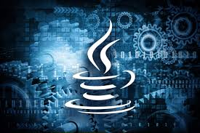

* + 1. **Key Features of Java Programming Language:**

**A. Platform Independence:**  
 **Java** programs are compiled into bytecode, which runs on the Java Virtual Machine (JVM). This means the same Java program can run on Windows, macOS, Linux, or any device with a JVM—no need to rewrite or recompile for each platform.

**B. Object-Oriented:**  
 **Java** is fully object-oriented, meaning everything is treated as an object. Concepts like **encapsulation** (hiding internal data), **inheritance** (reusing existing code), and **polymorphism** (one interface, many implementations) help organize and manage large programs more efficiently.

**C. Automatic Memory Management:**  
 **Java** uses a **garbage collector** to automatically handle memory allocation and deallocation. It frees up memory used by objects no longer in use, preventing memory leaks and reducing the chance of program crashes due to memory errors.

**D. Built-in Security:**  
 **Java** has several built-in security features, such as **bytecode verification**, **classloaders**, and a **security manager**. These work together to ensure code behaves safely, especially when running from untrusted sources like web browsers or networked environments.

**E. Multithreading Support:**  
 **Java** provides built-in support for **multithreading**, allowing multiple parts of a program to run concurrently. This makes it ideal for tasks like real-time data processing, animations, and responsive UI applications.

**F. Rich Standard Library:**  
 **Java** offers a massive collection of pre-built classes and packages (APIs) for things like **file handling**, **networking**, **data structures**, **database access**, and **graphical user interfaces (GUIs)**—saving time and effort for developers.

**G. Java Virtual Machine (JVM):** **The JVM** is the engine that runs Java bytecode. When you compile a Java program, it's converted into bytecode—not native machine code. The JVM interprets or compiles this bytecode into native code *at runtime*, depending on the device or OS. This is what gives Java its platform independence.

Beyond that, the JVM also:

* Manages memory through garbage collection.
* Provides built-in security and sandboxing.
* Handles exceptions and optimizes performance using Just-In-Time (JIT) compilation.

Thanks to the JVM, Java programs are portable, secure, and optimized across different systems—without needing to rewrite them.

* + 1. **Applications of Java:**

1. **Java and Web Development:**

**Java** is widely used to create **dynamic websites** and **web applications**. Frameworks like **Spring**, **Spring Boot**, and **JavaServer Faces (JSF)** make it easier to handle backend logic, databases, security, and APIs. Big websites and banking platforms often run on Java because of its speed and reliability.

**B. Java and Enterprise Systems:**

**Java** powers **large-scale enterprise applications** like **ERP** (Enterprise Resource Planning) and **CRM** (Customer Relationship Management). These systems handle thousands of users and massive data. Java EE (Jakarta EE) offers strong tools for scalability, transaction handling, and distributed computing—perfect for complex business apps.

**C. Java and Mobile Applications:**

**Java** is the **official language for Android development**. Using the **Android SDK**, developers write Java code to create mobile apps that run on millions of Android devices. It provides access to hardware, UI design, and other system services.

**D. Java and Desktop GUI Applications:**

**Java** supports desktop app development using **Swing** and **JavaFX**, which offer tools to build user interfaces (buttons, forms, tables, etc.). Though less common today for consumer apps, it's still used for internal business tools and educational software.

**E. Java and Embedded Systems & IoT:**

With **Java ME (Micro Edition)** and lightweight JVMs, **Java** can run on **small devices** like sensors, routers, smartcards, and appliances. It’s ideal for **IoT** (Internet of Things) projects where memory and power are limited, but secure and stable software is required.

**F. Java and Big Data & Scientific Computing:**

**Java** is used in **data-heavy environments** like **big data processing** with frameworks like **Apache Hadoop**, **Spark**, and **Storm**. It handles multithreading and large-scale data efficiently. Java is also used in scientific simulations and financial modeling.

**G. Java and Cloud Computing & Microservices:**

**Java** is great for **cloud-native** development. Tools like **Spring Boot** and **Micronaut** help developers build **microservices** that are small, independent, and scalable. These are often deployed in cloud platforms like AWS, Azure, and Google Cloud.

**H. Game Development:**

While not as popular as Unity or Unreal, **Java** is still used for 2D/3D games, especially in education or indie projects. Game engines like **LibGDX** use Java to create cross-platform games for desktop, web, and mobile. It's also used for server-side logic in multiplayer games.

* 1. **Introduction to the Spring Framework:**
     1. **Development History of Spring Framework:**

**The Spring Framework** began in October 2002 when Rod Johnson published Expert One‑on‑One J2EE Design and Development, proposing a lightweight, POJO‑based approach to J2EE development. In June 2003, the first public release—Spring 0.9—was made available under the Apache 2.0 license, laying the groundwork for its modular Inversion‑of‑Control container.

Spring 1.0 followed on March 24, 2004, introducing core features like dependency injection and Aspect‑Oriented Programming. Over the next several years, key milestones included Spring 2.0 (2006) with annotation support, Spring 3.0 (December 2009) adding RESTful web‑service capabilities, and Spring 4.0 (December 2013) bringing Java 8 compatibility and WebSocket integration.

On September 28, 2017, Spring 5.0 went GA, delivering reactive‑programming support via Spring WebFlux and deeper integration with JUnit 5 and Kotlin. Most recently, Spring 6.0 (November 22, 2022), Spring 6.1 (November 16, 2023), and Spring 6.2 (November 14, 2024) have moved the framework onto a Jakarta EE 9+ namespace and a Java 17+ baseline.

**∆:: The Timeline of Springboot’s evolution:**

**A. Early Origins (2002–2004):**  
 Rod Johnson’s *Expert One‑on‑One J2EE Design and Development* (October 1, 2002) laid out the concepts of a lightweight, POJO‑based container. He released the first source as Spring 0.9 under Apache 2.0 in June 2003, and Spring 1.0 followed on March 24, 2004, introducing core dependency‑injection (DI) and AOP support [Wikipedia](https://en.wikipedia.org/wiki/Spring_Framework).

**B. Maturation & Security (2005–2008):**  
 Spring 2.0 (October 2006) added annotation‑driven DI and expanded AOP; 2.5 (November 2007) improved data‐access and web‑MVC features [Wikipedia](https://en.wikipedia.org/wiki/Spring_Framework). In parallel, the Acegi Security project (late 2003) became Spring Security, with its first 2.0.0 release in April 2008, offering integrated authentication/authorization for enterprise apps [Wikipedia](https://en.wikipedia.org/wiki/Spring_Security?utm_source=chatgpt.com)[Home](https://docs.spring.io/spring-security/site/docs/3.0.x/reference/introduction.html?utm_source=chatgpt.com).

**C. Enterprise Growth & Corporate Backing (2009–2013):**  
 VMware acquired SpringSource in August 2009, cementing commercial support [Wikipedia](https://en.wikipedia.org/wiki/Spring_%28company%29?utm_source=chatgpt.com). Spring 3.0 (December 2009) introduced REST‑style web services; 3.1 (December 2011) added caching and scheduling; and 3.2 (November 2013) refined Java 8 compatibility. Meanwhile, Spring Data (2011) extended Spring’s reach to NoSQL stores like MongoDB and Redis [SpringOne](https://springone.io/history-of-spring?utm_source=chatgpt.com).

**D. Spring Boot & the Reactive/Cloud Era (2014–Present):**  
 Pivotal launched Spring Boot 1.0 GA on April 1, 2014 to simplify project bootstrap and auto‑configuration. Boot 2.0 arrived in March 2018 and Boot 3.0 in November 2022 (Jakarta EE 9+ baseline, GraalVM support). Spring Framework 5.0 (September 28, 2017) added reactive‑programming via WebFlux, and Spring 6.x (November 2022, 2023, 2024) moved fully to Jakarta EE 9+ and Java 17+ [Wikipedia](https://en.wikipedia.org/wiki/Spring_Framework).

Across these phases, Spring grew from a DI/AOP container to a full‑featured ecosystem—spanning security, data, microservices, cloud‑native, and reactive frameworks—now stewarded under VMware Tanzu’s open‑source umbrella.

* + 1. **Modules in the Spring Framework:**

**The Spring Framework** includes features organized into about 20 modules. These modules are grouped into Core Container, Data Access/Integration, Web, AOP (Aspect Oriented Programming), Instrumentation, Messaging, and Test, as shown in the following diagram.

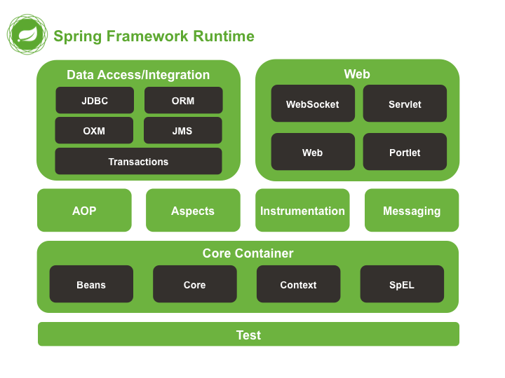

**A. Core Module:**  
 The Core module provides the fundamental features of the Spring Framework, particularly the concepts of Inversion of Control (IoC) and Dependency Injection (DI). It lays the foundation for creating and managing beans—the objects in your application—by supplying the BeanFactory interface, which is responsible for instantiating and wiring components together. It also offers essential utilities like resource loading and type conversion, which are heavily used across other Spring modules.

**B. Beans Module:**  
 The Beans module is centered around the configuration, creation, and management of application beans. It supports defining beans through XML files, annotations, or Java-based configuration. This module handles the full lifecycle of each bean, including initialization and destruction, while also allowing for different scopes such as singleton, prototype, or session-based. It is one of the most crucial modules for enabling modular, flexible application design.

**C. Context Module:**  
 Building on the Core and Beans modules, the Context module introduces a more advanced ApplicationContext interface, which offers features like internationalization (i18n), event publication, and application-layer specific functionalities. It also provides support for annotation-driven dependency injection (e.g., @Autowired) and configuration scanning (@ComponentScan). The context module is what allows Spring to act as a complete framework for building loosely coupled enterprise applications.

**D. SpEL (Spring Expression Language):**  
 The SpEL module adds powerful expression language support to Spring. It allows developers to embed expressions directly into configuration files or annotations, enabling dynamic property evaluation, method calls, conditional logic, and access to collection data. SpEL is especially useful in advanced bean definitions and is heavily used in Spring Security, Spring Data, and other frameworks built on top of Spring.

* + 1. **Projects in the Spring Framework:**

**A. Spring MVC:**  
 A web‑framework module built on the Core Container that implements the Model‑View‑Controller pattern. It handles HTTP requests, maps them to controller methods, and renders views (JSP, Thymeleaf, etc.), making it easy to build flexible, testable web applications.

**B. Spring Data:**  
 Provides a unified, repository‑style abstraction over various data stores (JPA, MongoDB, Redis, Elasticsearch, etc.). It auto‑generates queries from method names and integrates with Spring’s transaction and mapping facilities, drastically reducing boilerplate for CRUD and paging operations.

**C. Spring Security:**  
 A comprehensive, customizable authentication and authorization framework. It plugs into Spring MVC (and other HTTP endpoints) to secure URLs, method calls, and web services, offering features like form‑login, OAuth2, JWT, CSRF protection, and fine‑grained access control.

**D. Spring Boot:**  
 Opinionated “convention‑over‑configuration” layer that accelerates Spring application development via auto‑configuration, starter dependencies, and embedded servers (Tomcat, Jetty). It lets you get production‑ready apps up and running with minimal setup.

**E. Spring Batch:**  
 A lightweight batch‑processing framework designed for robust, high‑volume jobs. It provides reusable patterns for chunk‑oriented processing, transaction management, restartability, skip‑logic, and job monitoring—ideal for ETL, reports, or large data imports/exports.

**F. Spring Integration:**  
 Offers an extension of Spring’s programming model to support Enterprise Integration Patterns (EIP). It supplies adapters and channels for messaging, file‑transfer, web services, and more, enabling you to build event‑driven, message‑based architectures within the Spring container.

**G. Spring XD:**  
 An older, now‑superseded project for big‑data ingestion and real‑time stream/batch processing. It combined Spring Integration and Spring Batch under a unified runtime; its features have since been rolled into Spring Cloud Data Flow.

**H. Spring Social:**  
 A module for integrating OAuth‑based “social” logins and APIs (Facebook, Twitter, LinkedIn). It simplifies connecting your application to social providers for user authentication or data access, managing tokens, and binding API clients to your Spring beans.

* 1. **Introduction to Maven:**
     1. **What is Maven?**
* **Apache Maven** is a build‑automation and project‑management tool for Java (and other JVM) projects.



* It uses a **Project Object Model** (POM) file (pom.xml) as the single source of truth for build configuration.
* **Maven** standardizes the build process through a well‑defined **lifecycle** of phases and goals.
* It handles **dependency management**, automatically downloading required libraries into a local repository.
* The system is **extensible** via plugins and **configurable** through build profiles for different environments.

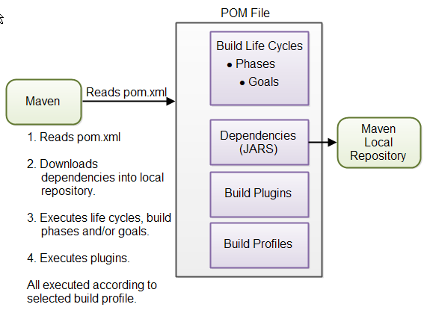

* + 1. **How Does Maven Work?**

|  |  |
| --- | --- |
| **Criteria** | **Steps** |
| **Read POM** | parses pom.xml to discover project settings, dependencies, plugins, lifecycles, and profiles. |
| **Resolve Dependencies** | downloads declared JARs (and their transitive dependencies) into your local Maven repository. |
| **Execute Lifecycle** | runs the standard build lifecycle (e.g., validate → compile → test → package → install → deploy). |
| **Run Plugins** | invokes any configured build plugins (for code generation, packaging, deployment, etc.), all scoped by the active build profile. |

* + 1. **Why Do We Need Maven?**
* Maven helps standardize the build process by managing tasks like compiling, testing, packaging, and deploying through a defined lifecycle. It simplifies dependency management via the pom.xml file and ensures consistent project structure. With powerful plugins and support for multi-module projects, it streamlines complex Java applications efficiently.
* For developers, Maven improves teamwork with a predictable layout and easy integration into IDEs and CI/CD tools like Jenkins. It reduces manual effort, minimizes errors, and speeds up project setup—making collaboration and delivery smoother and more reliable.
  1. **Introduction to MySQL:**
     1. **Overview of MySQL:**

**MySQL** is an open‑source, high‑performance relational database using SQL, originally developed in 1995 and now maintained by Oracle. It’s a core part of the LAMP stack and offers a pluggable storage‑engine architecture to meet diverse workload needs.

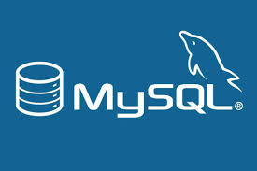

**∆:: Advantages of MySQL:**

* Open‑source and freely available (with optional commercial editions)
* Cross‑platform support (Linux, Windows, macOS)
* High performance and scalability for small to large datasets
* Flexible storage engines (InnoDB, MyISAM, etc.)
* ACID‑compliant transactions and reliable crash recovery
* Built‑in replication, clustering, and partitioning for high availability
* Strong community ecosystem plus enterprise support
* Rich tooling and integrations (GUI clients, connectors, monitoring)
* Robust security features (user authentication, SSL/TLS, encryption)
  + 1. **Introduction to MySQL Workbench:**

**MySQL Workbench** is the official, cross‑platform graphical tool for designing, developing, and administering MySQL databases. It brings a unified visual interface to everything from data modeling and SQL development to server configuration, user administration, and performance tuning—making complex tasks intuitive and efficient.

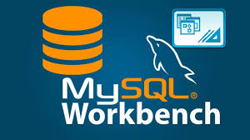

**∆:: Key Components & Features:**

|  |  |
| --- | --- |
| **Criteria** | **Key Components Purpose** |
| **SQL Editor** | Write, execute, and debug queries with syntax highlighting, auto‑completion, and visual explain plans |
| **Data Modeling** | Create and reverse‑engineer ER diagrams, manage schemas, and generate DDL scripts. |
| **Server Administration** | Configure server settings, manage users/privileges, monitor status variables, and view logs. |
| **Migration Wizard** | Automate migration from other RDBMS (Oracle, SQL Server, PostgreSQL) into MySQL. |
| **Performance Dashboard** | Track real‑time performance metrics, spot bottlenecks, and tune queries using visual dashboards. |
| **Backup & Recovery** | Schedule and execute logical backups, restores, and schema synchronizations. |
| **Visual Tools** | Manage indexes, foreign keys, triggers, and stored routines via point‑and‑click interfaces. |

With MySQL Workbench, both developers and DBAs gain a single, powerful environment to model data, build queries, and keep their MySQL servers running smoothly.

* 1. **Introduction to ReactJS:**
     1. **What is ReactJS?**

**ReactJS** is a lightweight JavaScript library (by Facebook) for building user interfaces using reusable, component‑based architecture. It lets you describe your UI in a **declarative** way and uses a **virtual DOM** to update only the parts of the page that change—making your apps fast, maintainable, and easy to reason about.



* + 1. **Advantages and Disadvantages of ReactJS:**
       1. **Advantages:**

• ReactJS lets you build UI from small, reusable pieces (components).

• ReactJS updates the page quickly by only changing what’s needed.

• ReactJS has a big community and lots of ready‑made tools.

• ReactJS uses JSX so you write HTML‑like code right in JavaScript.

* + - 1. **Disadvantages:**

• ReactJS only handles the view layer—you need other tools for state, routing, etc.

• ReactJS requires a build setup (Babel, Webpack) which can be tricky.

• ReactJS frequent updates mean you have to keep learning new patterns.

• ReactJS purely client‑side rendering can hurt SEO unless you add server‑side rendering.

* + 1. **Main Components of ReactJS:**

|  |  |
| --- | --- |
| **Criteria** | **Main Components Purpose** |
| **JSX** | A syntax extension that lets you write HTML‑like code in JavaScript for defining UI structure. |
| **Components** | Reusable, self‑contained pieces of UI. Can be functional (with Hooks) or class‑based. |
| **Props** | Read‑only inputs passed from parent to child components for configurability and data flow. |
| **State** | Internal, mutable data managed within a component that drives its rendering and behavior. |
| **Lifecycle Methods** | (Class components) Hooks like componentDidMount and componentWillUnmount that run at specific points in a component’s existence. |
| **Hooks** | Functions like useState and useEffect that let functional components manage state and side effects. |
| **Virtual DOM** | An in‑memory representation of the UI that React diffs against the real DOM to update only what’s changed. |

* + 1. **Core Features of ReactJS:**

|  |  |
| --- | --- |
| **Criteria** | **Core Features Purpose** |
| **Declarative Views** | Describe what the UI should look like for a given state, and React handles updating the DOM. |
| **Component-Based Architecture** | Build UIs from small, reusable, self-contained components. |
| **JSX Syntax** | Blend HTML‑like markup with JavaScript to define component structure clearly. |
| **Virtual DOM** | React keeps a lightweight copy of the DOM in memory and updates only what’s changed, for fast rendering. |
| **One‑Way Data Binding** | Data flows down from parent to child components via props, making state changes predictable. |
| **ks** | Manage component setup, updates, and cleanup through class methods or functional Hooks (useState, useEffect). |
| **Context API** | Share data across multiple components without passing props through every level, simplifying global state. |

* 1. **Introduction to IoT Sensors:**
     1. **What are IoT Sensors?**

**IoT (Internet of Things) sensors** are smart devices that detect and measure physical, environmental, or chemical conditions and convert these readings into digital signals. Connected to networks via wired or wireless technologies (e.g., Wi-Fi, Bluetooth, LoRaWAN), they enable real-time data collection and transmission to cloud platforms or local gateways for analysis and decision-making.

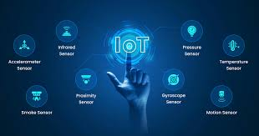

* + 1. **History and Development of IoT Sensor Technology:**

The concept of connected devices dates back to the early 1980s, with the first known IoT device being a Coca-Cola vending machine at Carnegie Mellon University that reported its inventory status online. The term “Internet of Things” was coined in 1999 by Kevin Ashton during his work on RFID technology at Procter & Gamble.

Through the 2000s, advances in wireless communication, cloud computing, and microelectronics spurred the development of more compact and affordable sensors. The rise of IPv6, low-power wireless technologies (like Zigbee and LoRa), and platforms for edge computing further enabled widespread IoT deployment.

In the 2010s, IoT ecosystems flourished with the proliferation of smartphones and cloud services. Sensor miniaturization and integration with AI opened up powerful new applications—from smart homes to precision agriculture and environmental monitoring. Today, IoT sensors are pivotal in shaping the digital transformation across industries, with ongoing innovation in nanotechnology, AI, and 5G further expanding their potential.

* + 1. **Types of IoT Sensors:**

|  |  |
| --- | --- |
| **Criteria** | **Type Purpose** |
| **Environmental Sensors** | Temperature, humidity, air quality (e.g., PM2.5, CO₂), pressure. |
| **Motion & Position Sensors** | Accelerometers, gyroscopes, magnetometers, GPS modules. |
| **Optical Sensors** | Light intensity (LDR), proximity, infrared. |
| **Acoustic Sensors** | Microphones, ultrasonic distance sensors. |
| **Chemical & Gas Sensors** | VOC detectors, CO, O₃, NO₂, methane. |
| **Biosensors** | Heart-rate, glucose monitors, wearable health trackers. |

* + 1. **Advantages and Limitations of IoT Sensors:**
       1. **Advantages:**

|  |  |
| --- | --- |
| **Criteria** | **Advantages** |
| **Real-Time Monitoring** | Enables continuous data collection and instant responses. |
| **Improved Efficiency** | Supports automation and predictive maintenance, reducing costs. |
| **Scalability** | Easily deployable across various environments. |
| **Data-Driven Decisions** | Provides insights that inform better management and planning. |

* + - 1. **Limitations:**

|  |  |
| --- | --- |
| **Criteria** | **Limitations** |
| **Security Risks** | Vulnerable to hacking and data breaches. |
| **Power Constraints** | Many sensors rely on limited battery power. |
| **Connectivity Dependence** | Performance may degrade in areas with poor network coverage. |
| **Data Overload** | Large volumes of raw data may require complex processing and storage solutions. |

* + 1. **Applications of IoT Sensors in Real Life:**

|  |  |
| --- | --- |
| **Criteria** | **Applications** |
| **Smart Cities** | Air-quality monitoring, traffic management, waste collection. |
| **Industry 4.0** | Predictive maintenance, asset tracking, process control. |
| **Healthcare** | Remote patient monitoring, smart wearables. |
| **Agriculture** | Soil moisture, nutrient levels, weather stations. |

* 1. **Introduction to Artificial Intelligence (AI) and Deep Learning:**
     1. **What is Artificial Intelligence (AI)?**

**Artificial Intelligence (AI)** refers to the simulation of human intelligence in machines that can learn, reason, and make decisions. In the context of IoT, AI enhances sensor data processing, enabling systems to detect patterns, predict events, and automate actions intelligently.

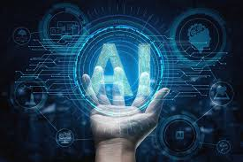

* + 1. **History and Development of AI:**

**Artificial Intelligence (AI**) emerged in the mid‑20th century, rooted in Alan Turing’s 1950 proposal of the "Turing Test" and formalized at the 1956 Dartmouth Conference led by **John McCarthy**. Early AI research focused on symbolic reasoning and expert systems in the 1960s and 1970s, but progress slowed during the "AI winters" of the 1980s due to computational and funding limitations. The revival in the 1990s brought statistical machine learning techniques, while the landmark 2006 work by Geoffrey Hinton sparked the modern deep learning revolution. Advances in GPU computing, algorithm design, and large datasets led to breakthroughs in neural network architectures—culminating in successes like AlexNet (2012) in computer vision. Today, AI and deep learning power applications across natural language processing, computer vision, and autonomous systems, driving innovation in IoT, healthcare, transportation, and beyond.

* + 1. **What is Deep Learning?**

**Deep Learning** is a specialized branch of AI based on neural networks with multiple layers (deep neural networks). It excels at handling large datasets and identifying complex patterns, especially in unstructured data like images or sensor signals.

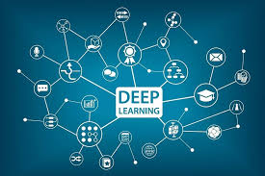

* + 1. **Differences Between AI, Machine Learning, and Deep Learning:**

While **Artificial Intelligence (AI)** encompasses the broad field of creating machines capable of human-like decision-making and problem-solving.

**Machine Learning (ML)** is a subset of AI focused on algorithms that improve through experience. ML techniques use statistical methods to enable computers to learn from data without explicit programming.

**Deep Learning (DL)** is a further subset of ML employing multi-layered neural networks to automatically learn hierarchical representations from large datasets, excelling in tasks like image and speech recognition where features are complex and unstructured.

|  |  |  |  |
| --- | --- | --- | --- |
| **Criteria** | **AI** | **Machine Learning** | **Deep Learning** |
| **Scope** | Encompasses all aspects of simulating intelligence and reasoning. | Focuses on algorithms that learn from data without explicit programming. | Utilizes multi-layered neural networks to learn hierarchical representations. |
| **Data Dependency** | May use rule-based logic or limited data. | Requires structured datasets for training. | Thrives on massive, unstructured datasets for feature learning. |
| **Complexity & Computing Power** | Can run on modest hardware; varies by algorithm. | Moderate computing resources; depends on model complexity. | Demands significant GPU/TPU resources for training deep networks. |
| **Feature Engineering** | Involves human-defined rules or logic. | Requires manual feature extraction and selection. | Automatically extracts features through its hidden layers. |
| **Applications** | Expert systems, robotics, planning, reasoning. | Regression, classification, clustering, and predictive modeling. | Computer vision, natural language processing, speech recognition, and autonomous systems. |

* + 1. **Core Features of Deep Learning:**

|  |  |
| --- | --- |
| **Criteria** | **Core Features Purpose** |
| **Hierarchical Representation Learning** | Deep networks learn layered, abstract features directly from raw data. |
| **Automatic Feature Extraction** | Eliminates manual engineering by discovering relevant patterns during training |
| **Non-linear Transformations** | Activation functions enable modeling complex relationships |
| **End-to-End Learning** | Direct mapping from input to output enhances performance and simplicity |
| **High Scalability** | Leverages parallel hardware (GPUs/TPUs) and large datasets to train massive models |
| **Transfer Learning** | Reuses pre-trained models to adapt to new tasks with limited data |
| **Regularization Techniques** | Dropout, batch normalization, and early stopping prevent overfitting |

* + 1. **Applications of AI and Deep Learning in Real Life:**

|  |  |
| --- | --- |
| **Criteria** | **Application Purpose** |
| **Healthcare Diagnostics** | AI-driven image analysis for early disease detection and personalized treatment plans. |
| **Autonomous Vehicles** | Deep learning models for object detection, lane recognition, and decision-making in self-driving cars. |
| **Smart Assistants** | Natural language understanding and speech recognition powering virtual assistants like Siri and Alexa. |
| **Predictive Maintenance** | Analyzing IoT sensor data to forecast equipment failures and schedule repairs proactively. |
| **Environmental Monitoring** | AI-enhanced analysis of sensor networks for accurate air quality forecasting and pollution hotspot identification. |
| **Recommendation Systems** | Personalized product and content suggestions in e-commerce and streaming platforms based on user behavior. |
| **Fraud Detection** | Real-time anomaly detection in financial transactions and cybersecurity applications. |
| **Language Translation** | Neural machine translation enabling accurate, context-aware multilingual communication. |

**PART 2**

**ANALYSIS AND DESIGN OF THE “AI-POWERED AIR QUALITY MONITORING SYSTEM”**

**2.1. SURVEY THE SITUATION:**

**2.1.1. In the world:**

**A. Widespread Pollution:** According to the 2024 World Air Quality Report by IQAir, only 17% of global cities met the World Health Organization's (WHO) air pollution guideline for PM2.5 levels.

**B. Most Polluted Countries:** Chad and Bangladesh topped the list of the most polluted countries, with PM2.5 levels exceeding WHO guidelines by up to 15 times.

**C. Health Impact:** The State of Global Air 2024 report indicates that air pollution was responsible for approximately 8.1 million deaths globally in 2021, making it the second leading risk factor for death worldwide. 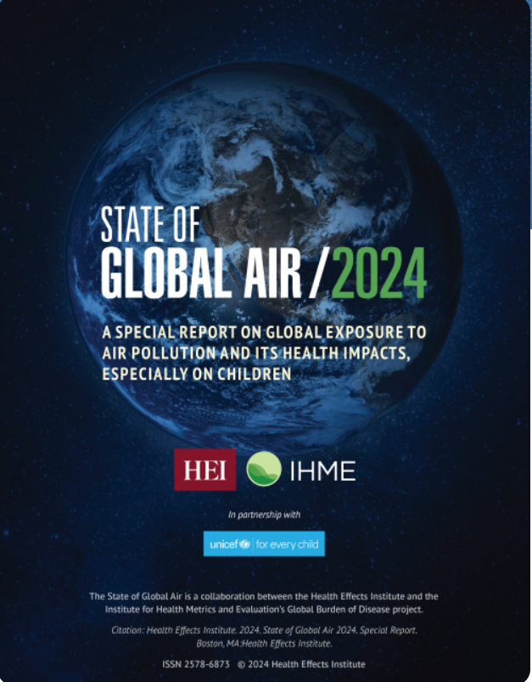

* **Countries Meeting WHO Standards:** Only seven countries met the WHO's annual average PM2.5 guideline of 5 µg/m³ in 2024: Australia, Bahamas, Barbados, Estonia, Grenada, Iceland, and New Zealand. ​
* **Cities with Clean Air:** Cities like Stockholm, Tokyo, and Canberra have been recognized for maintaining low air pollution levels, attributed to effective emission regulations, clean energy transitions, and investments in public transportation.

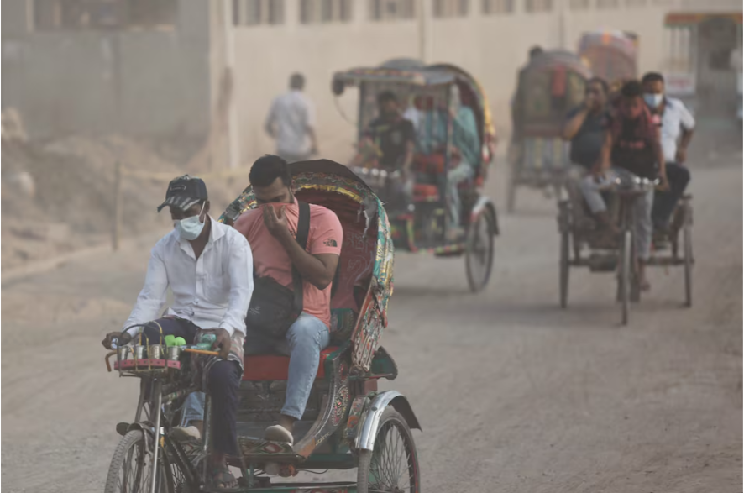

**2.1.2. In Vietnam:**

**A. Global Ranking**: Vietnam was ranked **22nd** in global air pollution levels in 2023, making it the **second most polluted country in Southeast Asia**, just after Indonesia.

**B. Hanoi's Air Quality**: The capital city, **Hanoi**, was identified as the **8th most polluted city worldwide** in 2023. In March of that year, residents experienced only one day with "moderate" air quality and none with "good" air quality.

**C. PM2.5 Levels**: The annual average **PM2.5 concentration** in Vietnam reached **29.6 µg/m³** in 2023, nearly **6 times higher** than the World Health Organization's recommended limit of 5 µg/m³.

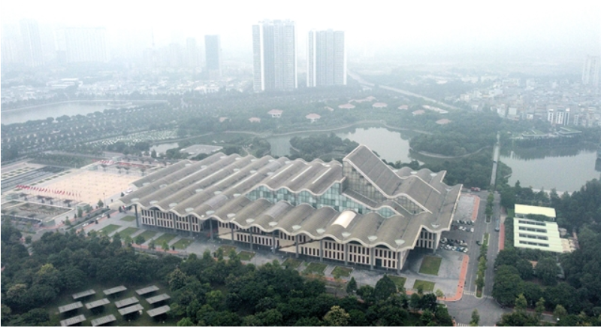

* **Monitoring Expansion**: Vietnam plans to construct **98 continuous automatic air quality monitoring stations** by 2030 to enhance data collection and public awareness.
* **Hanoi's Targets**: Hanoi aims to ensure that up to **80% of the days** in a year have air quality levels rated as good or moderate, based on data from standard national and city monitoring stations.

**2.2. SOME WEBSITES TO VIEW AIR QUALITY INDEX (AQI):**

* **IQAir:**

Link: <https://www.iqair.com/vi/>

Advantages: The web content is clear, specific and shows each air quality index. It is possible to specify the location to view air quality data.

Disadvantages: The web content so many detail, that make it become lag and vulnerable to some weak laptop.

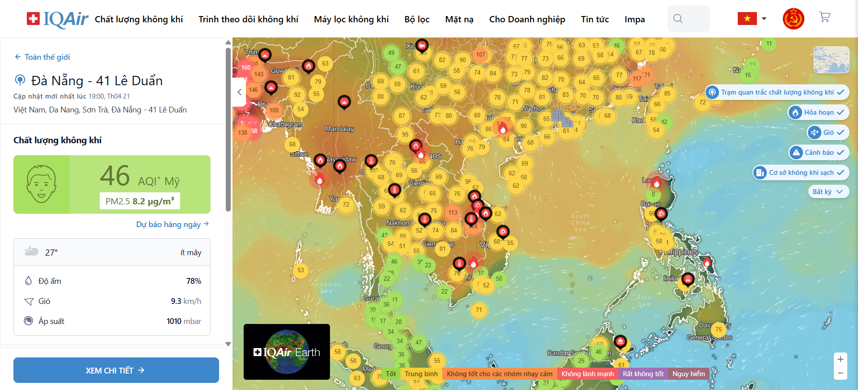

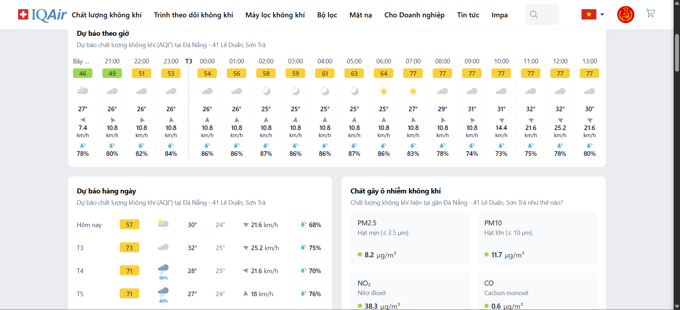

* **World's Air Pollution: Real-time Air Quality Index**

Link: <https://waqi.info/#/c/4.119/8.212/2.2z>

Advantages: Good content, with indicators displayed on the map. Complete and reputable data.

Disadvantages: The web content so many detail, that make it become lag and vulnerable to some weak laptop.

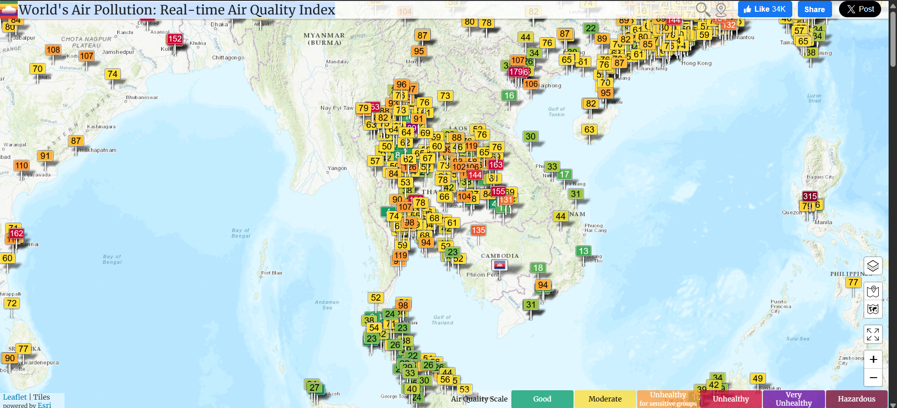

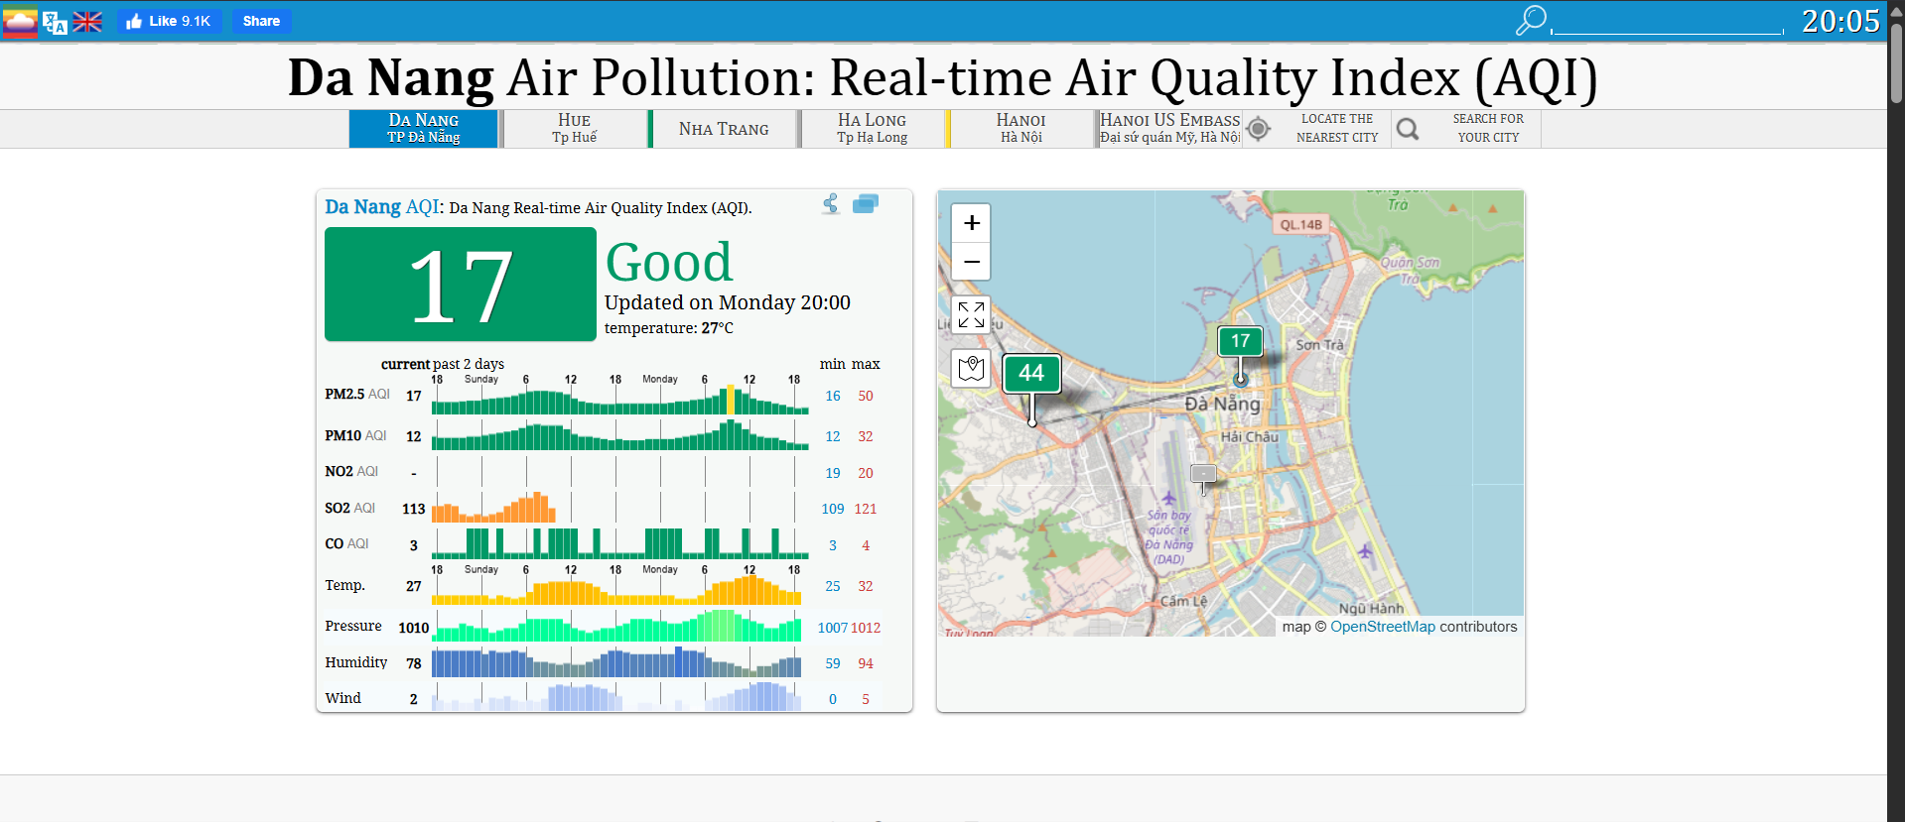

**2.3. OBJECTS INTERACTING WITH THE SYSTEM:**

The system has actors: Guest, User, Admin, Sensor.

The roles of the actors are shown in table… as follow:

|  |  |  |
| --- | --- | --- |
| NUM | Actor | Describe |
| 1 | Guest | Guest who are not logged in have access only to some general information about air quality and environmental indicators. |
| 2 | User | Registered users can personalize data displays, receive alerts, and track air quality history and forecasts. |
| 3 | Admin | System administrator, responsible for managing sensor data, setting alarm thresholds, processing reports, and approving system-related content. |
| 4 | Sensor | The device collects environmental data (pollution index, temperature, humidity, etc.) and sends the data continuously to the system. |

**2.4. USECASE DIAGRAM:**

**2.4.1. Main usecase:**

* Main usecase:

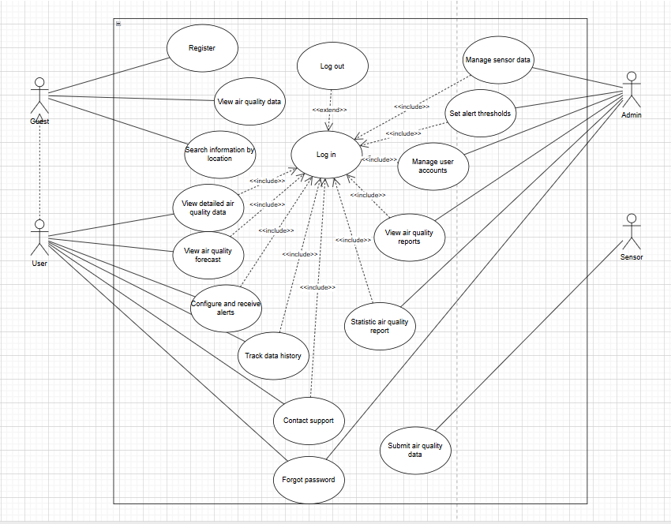

* Guest’s main usecase:

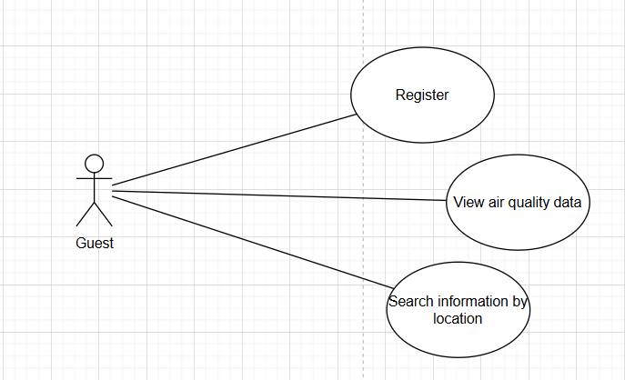

* User’s main usecase:

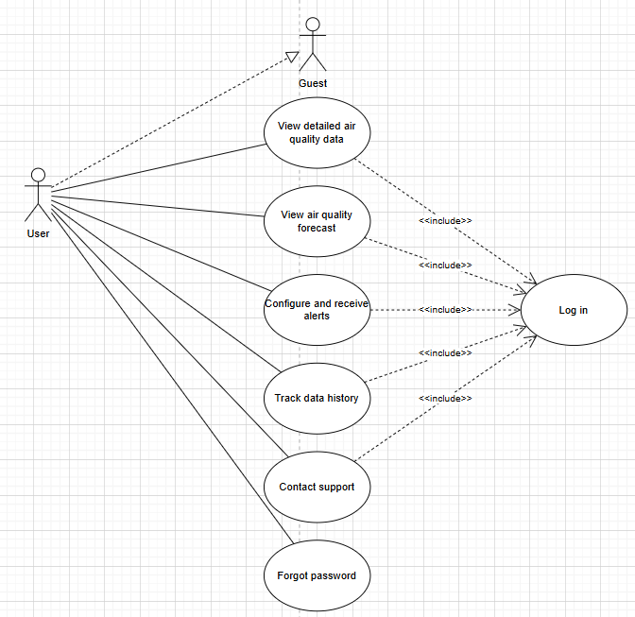

* Admin’s main usecase:

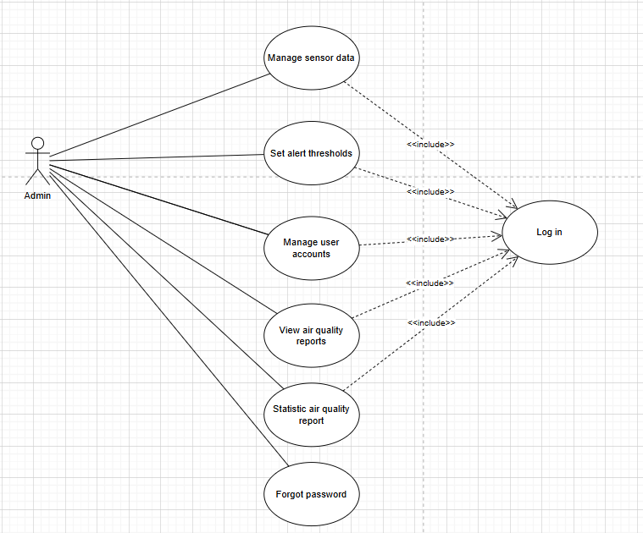

* Sensor’s main usecase:

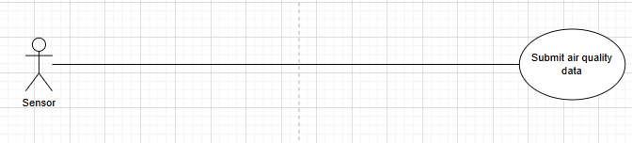

**2.4.2. Detail usecases:**

**2.4.2.1. (Guest) Register usecase:**

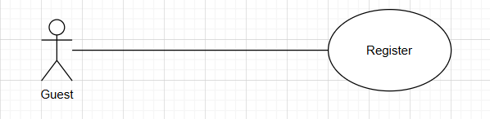

**Purpose: Guests** register an account to access additional features.

**Actors and General Description:**

* **Actors:** Guest.
* **General Description:** Describes the process of a user registering a new account.

**Main Event Flow:**

|  |  |
| --- | --- |
| Actor's Action | System Response |
| 1. User selects the "**Register Account**" option.  -  3. Enters registration information.  4. Submits the registration information.  -  - | -  2. Displays the account registration form.  -  -  5. Validates the information. If valid, shows success message; otherwise, shows error.  6. Ends the use case. |

**Alternative Flow:** If the registration information is invalid, the system prompts the guest to re-enter it.

**Specific Requirements:** Phone number and email must be entered in the correct format.

**Preconditions:** None.

**Postconditions:** None.

**2.4.2.2. (Guest) View air quality data usecase:**

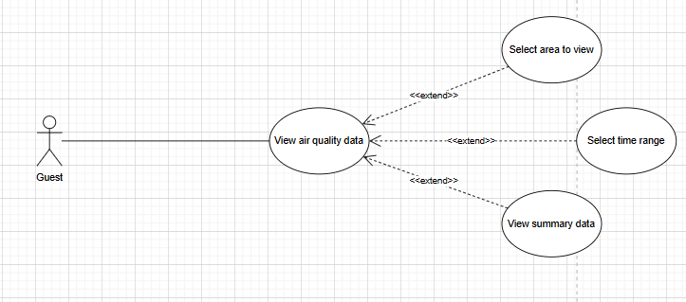

**Purpose:** Allow **guests** to view air quality data posts.

**Actors and General Description:**

* **Actors:** Guest.
* **General Description:** Describes the process by which a guest views the content of a data post.

**Main Event Flow:**

|  |  |
| --- | --- |
| Actor's Action | System Response |
| 1. Guest selects a data post.  -  - | -  2. Displays the data post content form.  3. Ends the use case. |

**Alternative Flow:** None.

**Specific Requirements:** None.

**Preconditions:** None.

**Postconditions:** None.

**2.4.2.3. (Guest) Search information by location usecase:**

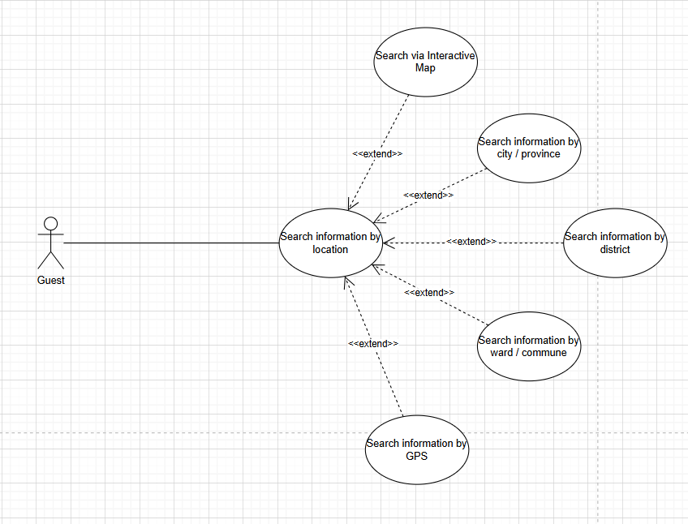

**Purpose: Guests** allow to search the data article.

**Actors and General Description:**

* **Actors:** Guest.
* **General Description:** Describes the process of a guest searching information from the relevant locations.

**Main Event Flow:**

|  |  |
| --- | --- |
| Actor's Action | System Response |
| 1. Enter search content into the search box.  2. Submit the entered information to the system  - | -  -  3. Display the list of found location.  4. End of use case |

**Alternative Flow:** None.

**Specific Requirements:** None.

**Preconditions:** None.

**Postconditions:** None.

**2.4.2.4. (User) Log in usecase:**

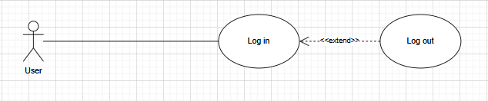

**Purpose:** Ensure **users** information authentication and system security.

**Actors and General Description:**

* **Actors:** User.
* **General Description:** Describes the process of a user logging into the system.

**Main Event Flow:**

|  |  |
| --- | --- |
| Actor's Action | System Response |
| 1. The user selects the login option..  -  3. User enters login information..  4. User submits login information.  -  - | -  2. The login form is displayed.  -  -  5. System authenticates the account. If correct, login is granted; otherwise, it is denied.  6. End of Use Case. |

**Alternative Flow:** If the user enters incorrect information, the system requests a re-entry.

**Specific Requirements:** Username and password must match the registered information.

**Precondition:** The user already has an account.

**Postcondition:** If login is successful, redirect to the homepage.

**2.4.2.5. (User) View detailed air quality data usecase:**

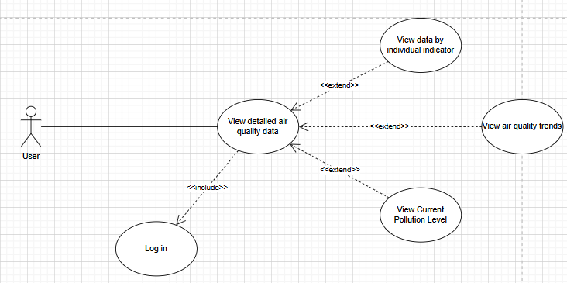

**Purpose:** Allow **users** to view detailed information of an air quality data post.

**Actors and General Description:**

* **Actors:** User.
* **General Description:** Describes the process of a registered user accessing detailed air quality information.

**Main Event Flow:**

|  |  |
| --- | --- |
| Actor's Action | System Response |
| 1. User selects a data post.  -  -  3. User selects “**View Details**”  -  - | -  2. Displays summary of the selected data post.  -  4. Displays full, detailed air quality information  5. Ends the use case. |

**Alternative Flow:** None.

**Specific Requirements:** User must be logged in.

**Preconditions:** User account exists and is authenticated.

**Postconditions:** Detailed data is successfully displayed.

**2.4.2.6. (User) View air quality forecast usecase:**

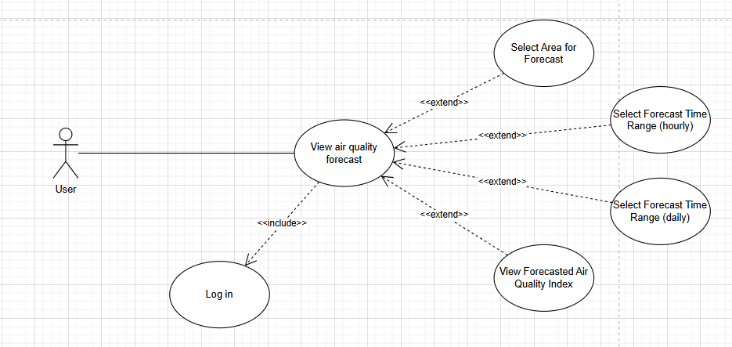

**Purpose:** Allow **users** to view upcoming air quality forecasts for a specific location.

**Actors and General Description:**

* **Actors:** User.
* **General Description:** Describes the process of a registered user viewing predicted air quality data based on time and location.

**Main Event Flow:**

|  |  |
| --- | --- |
| Actor's Action | System Response |
| 1. User selects “**Air Quality Forecast**”.  -  3. User inputs location and timeframe.  -  - | -  2. Displays a form to choose location and timeframe.  -  4. Displays forecasted air quality data.  5. Ends the use case. |

**Alternative Flow:** If no forecast data is available for the selected location or time, the system displays a “No data available” message.

**Specific Requirements:** User must be logged in.

**Preconditions:** Valid user session and internet connection.

**Postconditions:** Forecast data is successfully shown or system notifies if unavailable.

**2.4.2.7. (User) Configure and receive alerts usecase:**

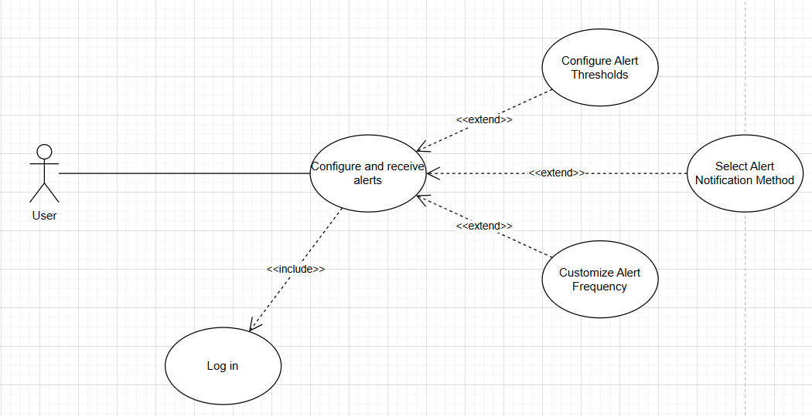

**Purpose:** Enable **users** to configure notification preferences and receive alerts based on specific air quality conditions.

**Actors and General Description:**

* **Actors:** User.
* **General Description:** Describes how a registered user sets alert criteria (e.g., location, pollutant type, threshold), and how the system sends real-time notifications when conditions match.

**Main Event Flow:**

|  |  |
| --- | --- |
| Actor's Action | System Response |
| 1. User navigates to “**Alert Settings**.”  -  3. User sets preferences (e.g., PM2.5 > 100).  5. System monitors data in real-time.  - | -  2. Displays alert configuration form.  -  4. Saves settings and confirms success.  5. If conditions match, sends alert via email or app.  6. Ends the use case. |

**Alternative Flow:** If user inputs invalid criteria, the system prompts for correction.

**Specific Requirements:**.

* Must be logged in.
* Must allow notifications from the app/system.

**Preconditions:** User has a registered account and access to alert settings.

**Postconditions:** Alerts are activated and delivered when conditions are met.

**2.4.2.8. (User) Track data history usecase:**

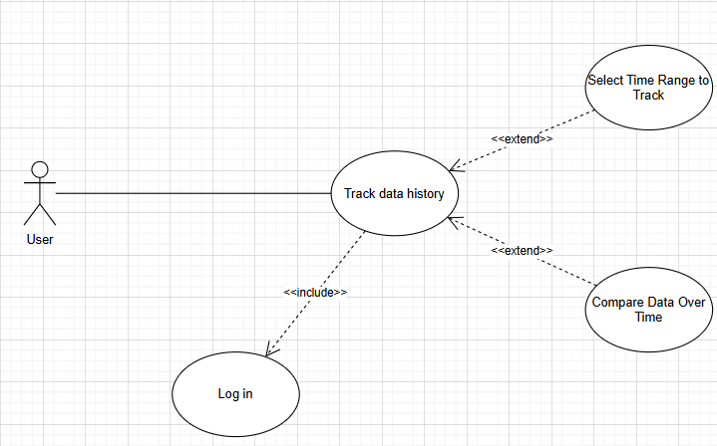

**Purpose:** Enable **users** to configure notification preferences and receive alerts based on specific air quality conditions.

**Actors and General Description:**

* **Actors:** User.
* **General Description:** Describes how a registered user sets alert criteria (e.g., location, pollutant type, threshold), and how the system sends real-time notifications when conditions match.

**Main Event Flow:**

|  |  |
| --- | --- |
| Actor's Action | System Response |
| 1. User navigates to “**Alert Settings**.”  -  3. User sets preferences (e.g., PM2.5 > 100).  5. System monitors data in real-time.  - | -  2. Displays alert configuration form.  -  4. Saves settings and confirms success.  5. If conditions match, sends alert via email or app.  6. Ends the use case. |

**Alternative Flow:** If user inputs invalid criteria, the system prompts for correction.

**Specific Requirements:**.

* Must be logged in.
* Must allow notifications from the app/system.

**Preconditions:** User has a registered account and access to alert settings.

**Postconditions:** Alerts are activated and delivered when conditions are met.

**2.4.2.9. (User) Contact support usecase:**

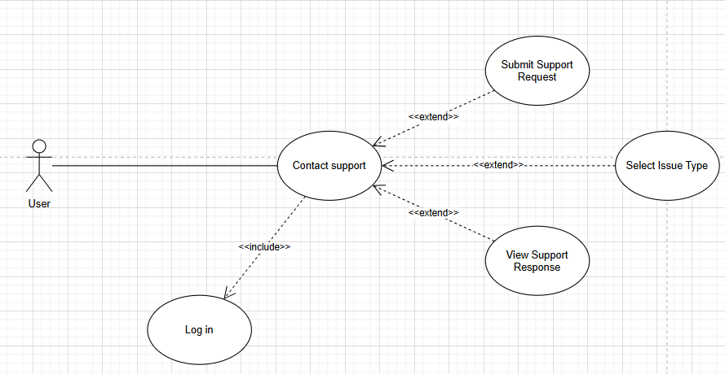

**Purpose:** Allow **users** to request assistance or report issues to the support team.

**Actors and General Description:**

* **Actors:** User.
* **General Description:** Describes the process of a registered user contacting the system’s support team via a form or message.

**Main Event Flow:**

|  |  |
| --- | --- |
| Actor's Action | System Response |
| 1. User selects “**Contact Support.”**  -  3. User enters issue/message details.  4. User submits the support request.  -  - | -  2. Displays the contact support form.  -  -  5. Confirms receipt and notifies support team.  6. Ends the use case. |

**Alternative Flow:** If the message is incomplete or invalid, system requests corrections.

**Specific Requirements:** Input must include a message or description of the issue.

**Preconditions:** User is logged in to access the support feature.

**Postconditions:** Support request is successfully logged for follow-up.

**2.4.2.10. (User/Admin) Forgot password usecase:**

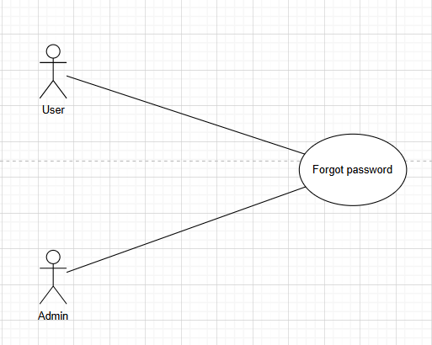

**Purpose:** Allow **users** to recover access to their account when they forget their password.

**Actors and General Description:**

* **Actors:** User, Admin.
* **General Description:** Describes the process of a user initiating a password reset request and the system (or admin) verifying and facilitating the password recovery.

**Main Event Flow:**

|  |  |
| --- | --- |
| Actor's Action | System Response |
| 1. User selects "**Forgot Password**."  -  3. User enters registered email/username.  4. User submits the recovery request.  -  6. User follows the link and sets a new password  - | -  2. Displays password recovery form.  -  -  5. Verifies user identity and sends reset instructions.  -  7. Confirms password change and ends the use case. |

**Alternative Flow:** If system verification fails, the request is denied or forwarded to Admin for manual assistance.

**Specific Requirements:**

* Registered email or username must be correct.
* Reset link expires after a defined time..

**Preconditions:** User must have an existing account.

**Postconditions:** User’s password is updated and access is restored.

**2.4.2.11. (Admin) Log in usecase:**

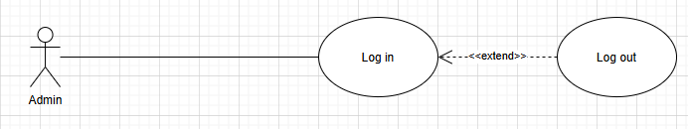

**Purpose:** Ensure **admin** authentication and secure system access.

**Actors and General Description:**

* **Actors:** Admin.
* **General Description:** Describes the process of an admin logging into the system using their credentials.

**Main Event Flow:**

|  |  |
| --- | --- |
| Actor's Action | System Response |
| 1. Admin selects "**Log in."**  -  3. Admin enters credentials (username & password).  4. Admin submits the login request.  -  -  - | -  2. Displays the login form.  -  -  5. Authenticates credentials; grants access if correct.  6. Redirects to admin dashboard.  7. Ends the use case. |

**Alternative Flow:** If credentials are incorrect, the system displays an error message and prompts for re-entry.

**Specific Requirements:**

* Admin credentials must match the registered records.
* System should lock account after multiple failed attempts (if configured).

**Precondition:** Admin account must already exist in the system.

**Postcondition:** Admin gains access to administrative functionalities.

**2.4.2.12. (Admin) Manage sensor data usecase:**

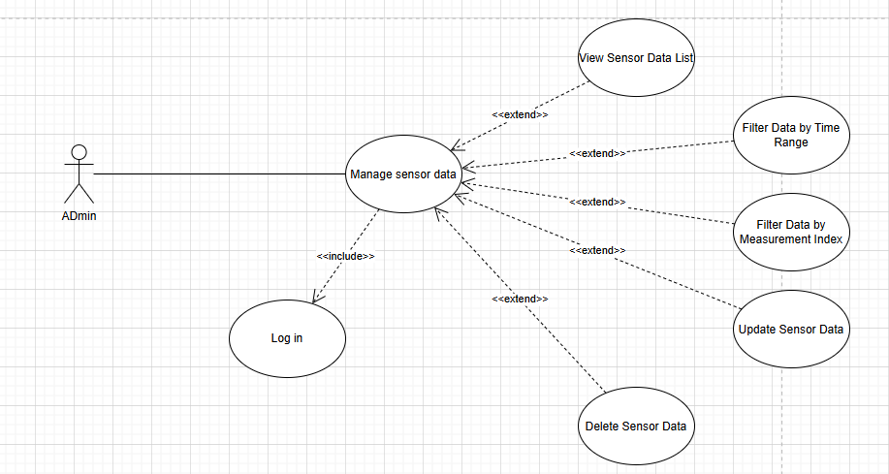

**Purpose:** Allow the **admin** to manage air quality sensor data for accuracy, maintenance, or system updates.

**Actors and General Description:**

* **Actors:** Admin.
* **General Description:**Describes the process by which the admin views, edits, deletes, or updates sensor data within the system.

**Main Event Flow:**

|  |  |
| --- | --- |
| Actor's Action | System Response |
| 1. Admin logs in and navigates to sensor data managent.  -  3. Admin selects a data entry to modify.  4. Admin edits or deletes the data.  -  6. Admin repeats or exits the session  - | -  2. Displays the login form.  -  -  5. Saves changes and confirms successful operation.  -  7. Ends the use case. |

**Alternative Flow:** If the selected data entry is invalid or restricted, the system notifies the admin and cancels the action.

**Specific Requirements:**

* Only admin can access and modify sensor data.
* All changes are logged for auditing.

**Precondition:** Admin must be authenticated and authorized.

**Postcondition:** Sensor data is updated or deleted as per the admin’s input.

**2.4.2.13. (Admin) Set alert thresholds usecase:**

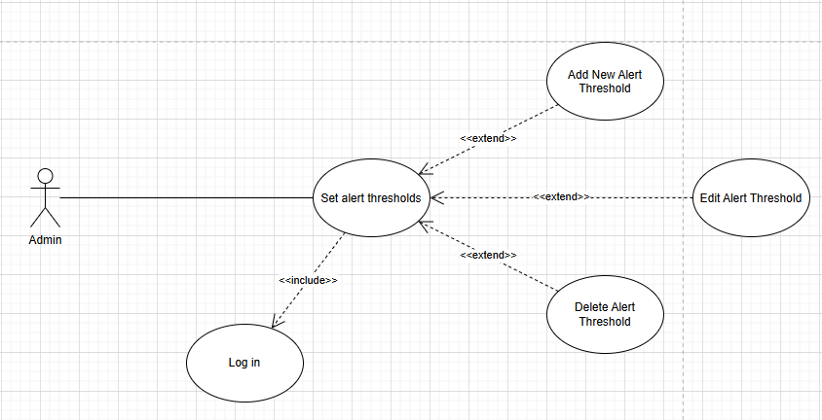

**Purpose:** Allow the **admin** to define or update threshold levels that trigger alerts when air quality data exceeds safe limits.

**Actors and General Description:**

* **Actors:** Admin.
* **General Description:** Describes the process of setting air quality parameter thresholds to activate notifications or system responses when exceeded.

**Main Event Flow:**

|  |  |
| --- | --- |
| Actor's Action | System Response |
| 1. Admin accesses the alert setting section.  -  3. Admin updates or defines new threshold values.  4. Admin submits the updated thresholds.  -  - | -  2. Displays current thresholds and editable.  -  -  5. System saves and applies the new threshold settings.  6. Ends the use case. |

**Alternative Flow:** If the threshold values are outside acceptable limits or incorrectly formatted, the system prompts for correction.

**Specific Requirements:**

* Only admins have permission to configure threshold settings.
* Change should be validated before saving.

**Precondition:** Admin must be logged in with proper privileges.

**Postcondition:** System uses the new threshold values to trigger future alerts.

**2.4.2.14. (Admin) Manage user accounts usecase:**

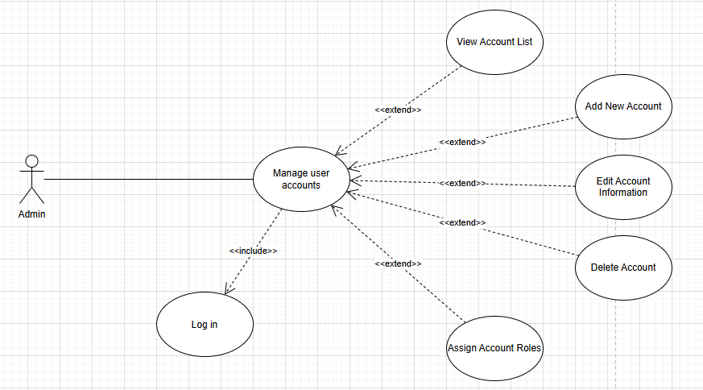

**Purpose:** Allow the **admin** to create, edit, and remove user accounts to maintain system access control.

**Actors and General Description:**

* **Actors:** Admin.
* **General Description:** Describes the process by which the admin manages registered user accounts. Including creating, updating, and deleting accounts.

**Main Event Flow:**

|  |  |
| --- | --- |
| Actor's Action | System Response |
| 1. Admin accesses the user managent panel.  -  3. Admin selects a user account to edit, delete, or add a new one.  4. Admin performs the chosen action (add/ edit/delete).  -  - | -  2. Displays a list of all registered users.  -  -  5.System updates the user database accordingly.  6. Ends the use case. |

**Alternative Flow:** If provided user data is invalid or missing, the system prompts the admin to revise the input.

**Specific Requirements:**

* Only admins have access to the user management interface.
* Each user account must have a unique email or username.

**Precondition:** Admin must be logged in with proper administrative privileges.

**Postcondition:** User accounts are updated according to the admin’s changes.

**2.4.2.15. (Admin) View air quality reports usecase:**

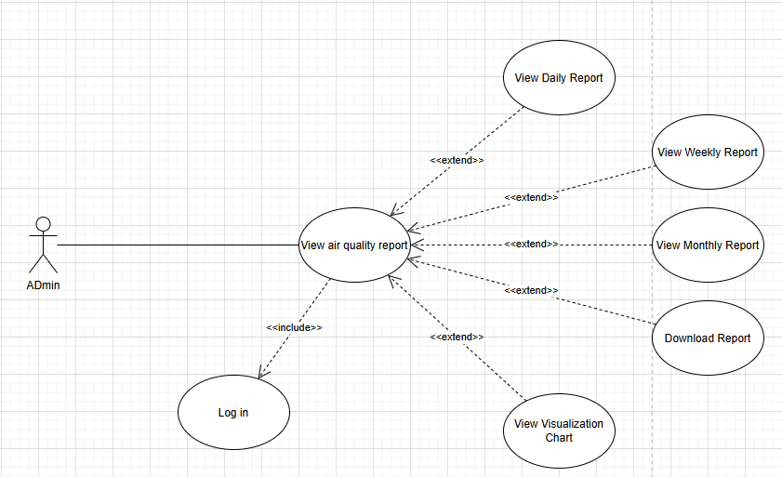

**Purpose:** Allow the **admin** to view comprehensive reports on air quality data collected from **sensors**.

**Actors and General Description:**

* **Actors:** Admin.
* **General Description:** Describes how the admin accesses and reviews detailed air quality reports generated from sensor data over specific timeframes or locationss.

**Main Event Flow:**

|  |  |
| --- | --- |
| Actor's Action | System Response |
| 1. Admin navigates to the report section.  -  3. Admin selects a report criteria (e.g., location, date range).  4. Admin requests to view the report.  -  - | -  2. Displays a list or filter options for report types.  -  -  5. System generates and displays the air quality report.  6. Ends the use case. |

**Alternative Flow:** If no data matches the selected criteria, the system notifies the admin and suggests changing the filters.

**Specific Requirements:**

* Reports may include graphs, averages, anomalies, and downloadable formats.
* Admin can export reports as PDF or CSV.

**Precondition:** Admin must be authenticated and authorized to view reports.

**Postcondition:** The selected air quality report is displayed or downloaded.

**2.4.2.16. (Admin) Statistic air quality report usecase:**

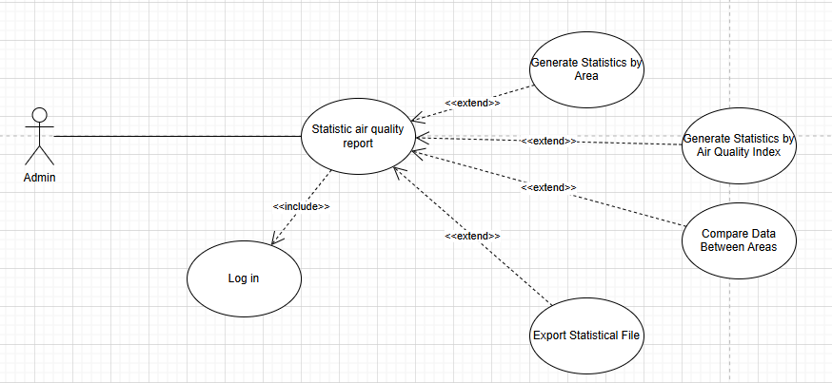

**Purpose:** Enable the **admin** to generate and analyze statistical reports based on collected air quality data.

**Actors and General Description:**

* **Actors:** Admin.
* **General Description:** Describes how the admin selects parameters to generate statistical summaries, trends, and insights from air quality data.

**Main Event Flow:**

|  |  |
| --- | --- |
| Actor's Action | System Response |
| 1. Admin naviagates to the statistics section.  -  3. Admin inputs desired criteria.  4. Admin requests statistical report.  -  - | -  2. Displays options to select location, date range, and metrics.  -  -  5. System processes data and presents statistical visualizations and summaries.  6. Ends the use case. |

**Alternative Flow:** If input criteria result in insufficient data, the system prompts the admin to adjust parameters.

**Specific Requirements:**

* Statistics may include averages, peaks, variance, trends, and comparions over time.
* Graphs and charts are auto-generated.
* Export options available (PDF, Excel).

**Precondition:** Admin must be logged in and have data access privileges.

**Postcondition:** Statistical air quality report is generated and displayed.

**2.4.2.17. (Sensor) Submit air quality data usecase:**

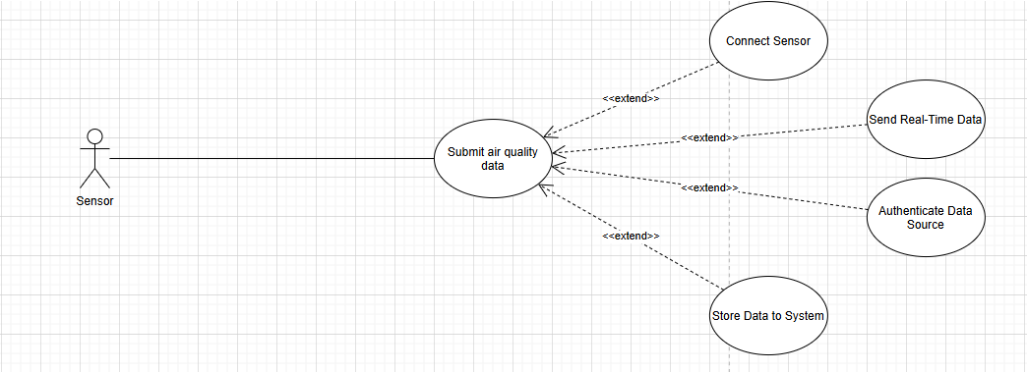

**Purpose:** Allow **IoT sensors** to automatically submit realtime air quality data to the system.

**Actors and General Description:**

* **Actors:** Sensor.
* **General Description:** Describes the automated process of sensors transmitting environmental readings to the backend server for storage and analysis.

**Main Event Flow:**

|  |  |
| --- | --- |
| Actor's Action | System Response |
| 1. Sensor collect air quality data.  2. Sensor transmits data to the system.  -  -  - | -  -  3. System receives and validates the data format and source.  4. System stores the data in the database.  5. Ends the use case. |

**Alternative Flow:** If the data format is invalid or transmission fails, the system logs the error and may request retransmission.

**Specific Requirements:**

* Data must include timestamp, location, and pollutant levels.
* Communication uses secure protocols (e.g., MQTT, HTTPS).

**Precondition:** Sensor is powered on, connected, and properly configred.

**Postcondition:** New air quality data is successfully stored in the system.

**2.5. SEQUENCE DIAGRAM:**

**2.5.1. (Guest) Register Sequence Diagram:**

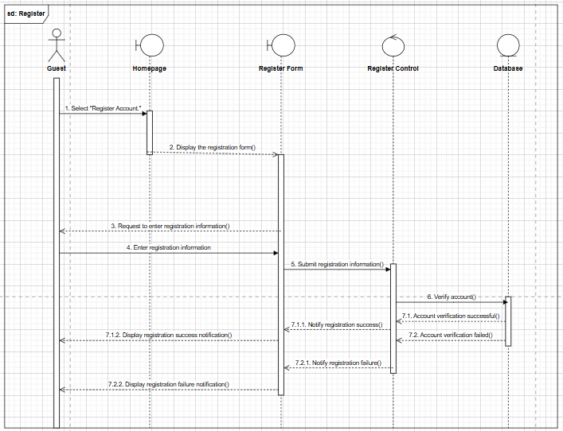

**2.5.2. (Guest) View air quality data Sequence Diagram:**

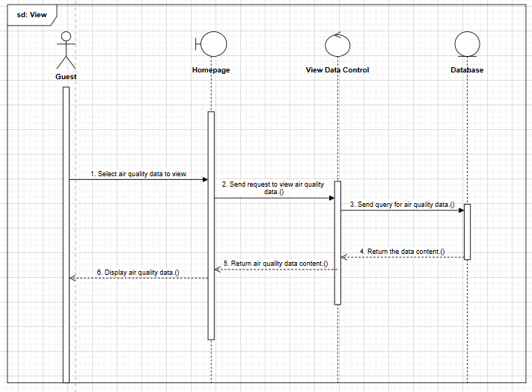

**2.5.3. (Guest) Search information by location Sequence Diagram:**

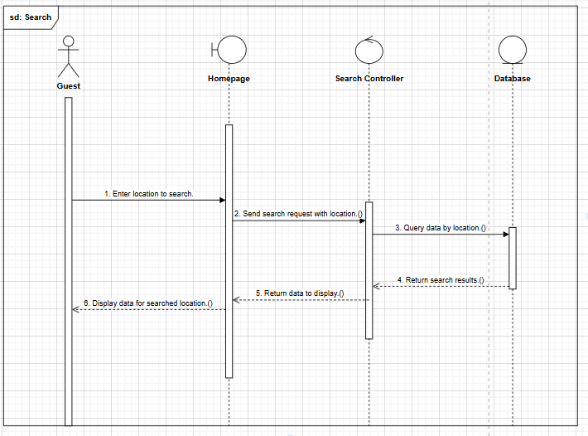

**2.5.4. (User) Log in Sequence Diagram:**

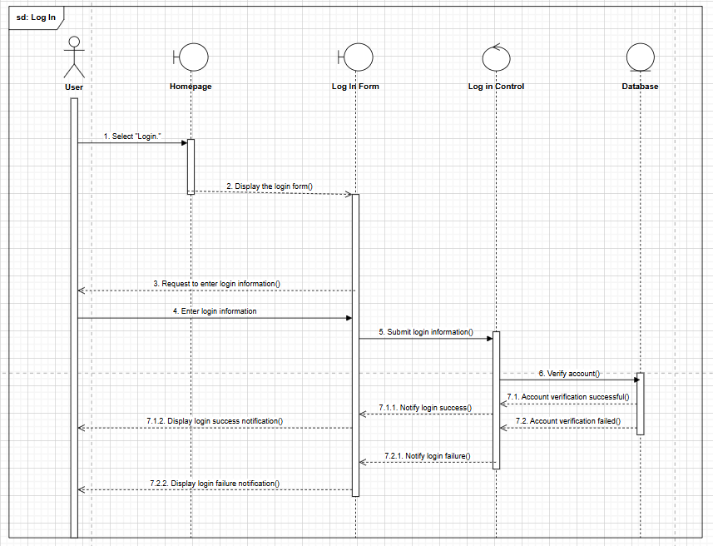

**2.5.5. (User) View detailed air quality data Sequence Diagram:**

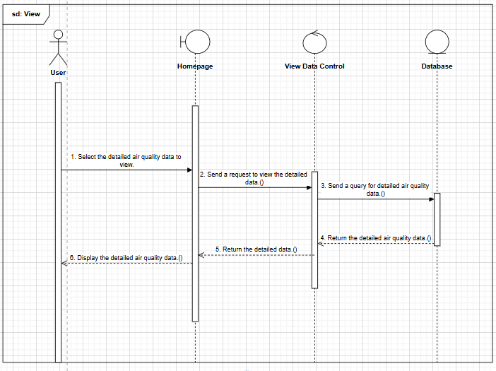

**2.5.6. (User) View air quality forecast Sequence Diagram:**

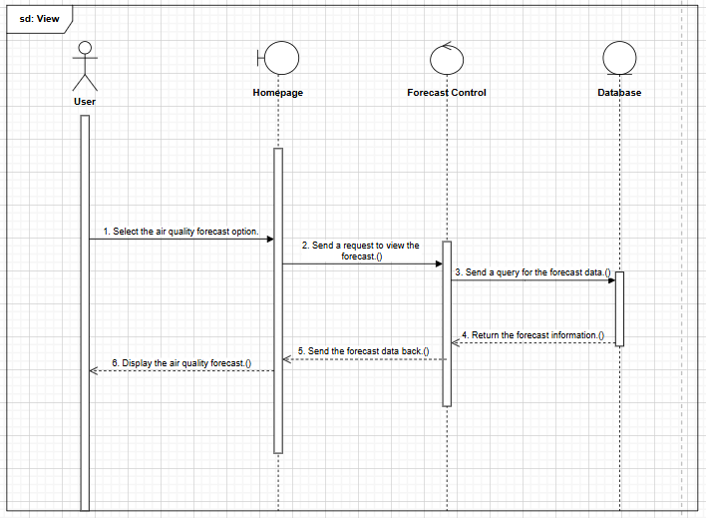

**2.5.7. (User) Configure and receive alert Sequence Diagram:**

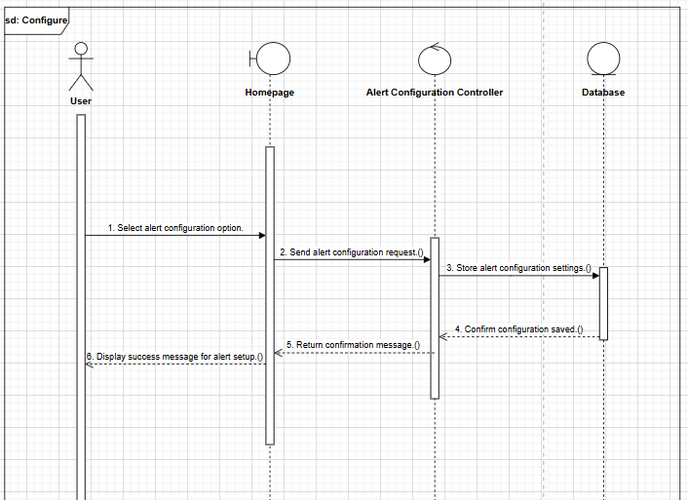

**2.5.8. (User) Track data history Sequence Diagram:**

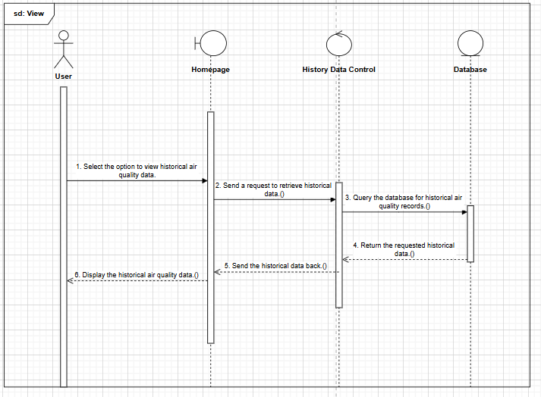

**2.5.9. (User) Contact support Sequence Diagram:**

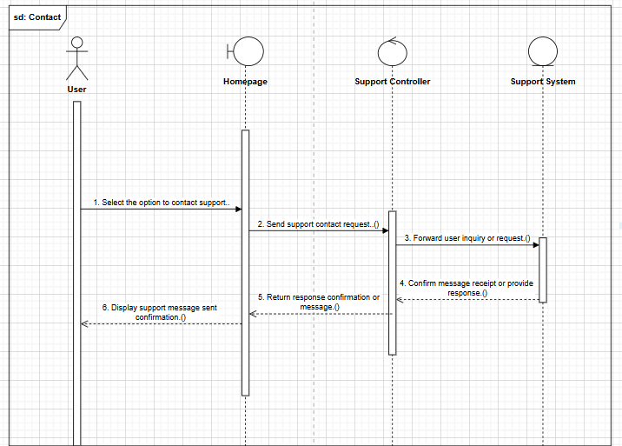

**2.5.10. (User/Admin) Forgot password Sequence Diagram:**

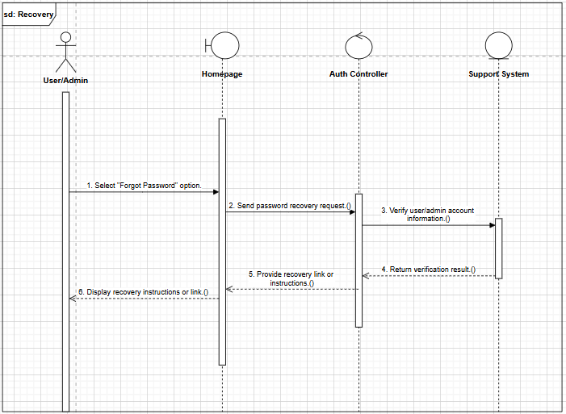

**2.5.11. (Admin) Log in Sequence Diagram:**

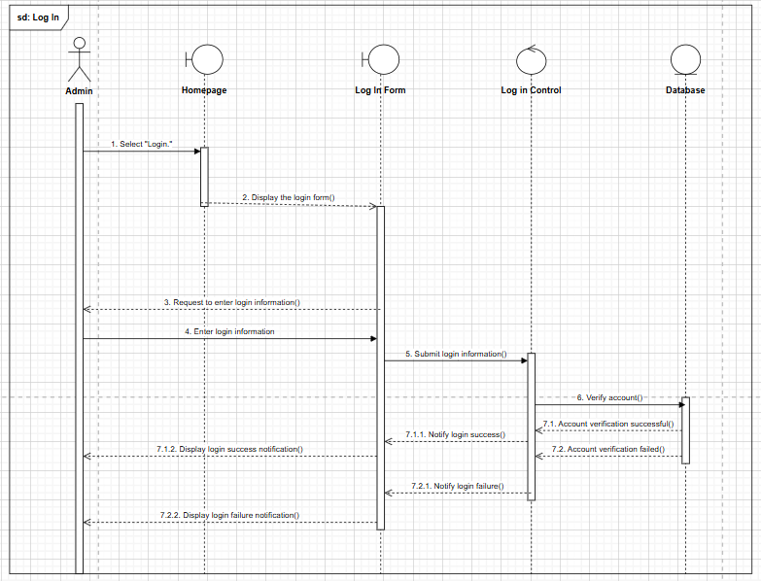

**2.5.12. (Admin) Manage sensor data Sequence Diagram:**

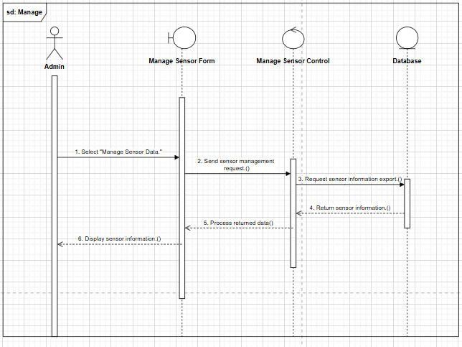

**2.5.13. (Admin) Update Sensor Data Sequence Diagram:**

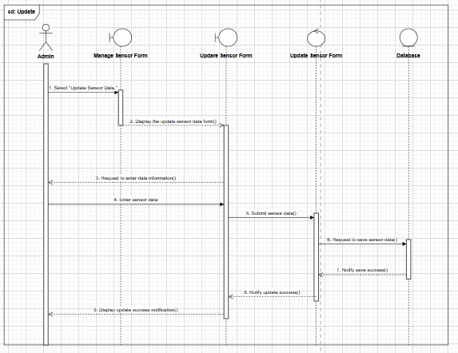

**2.5.14. (Admin) Delete Sensor Data Sequence Diagram:**

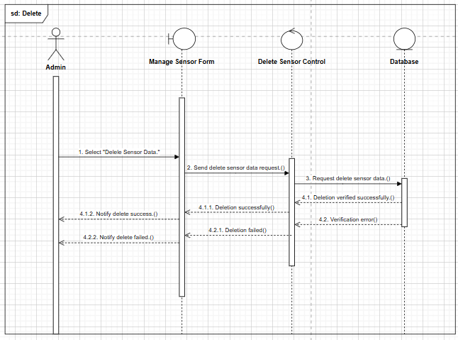

**2.5.15. (Admin) Set alert thresholds Sequence Diagram:**

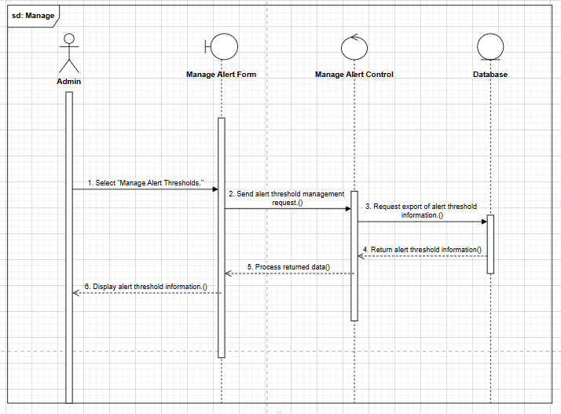

**2.5.16. (Admin) Add New Alert Threshold Sequence Diagram:**

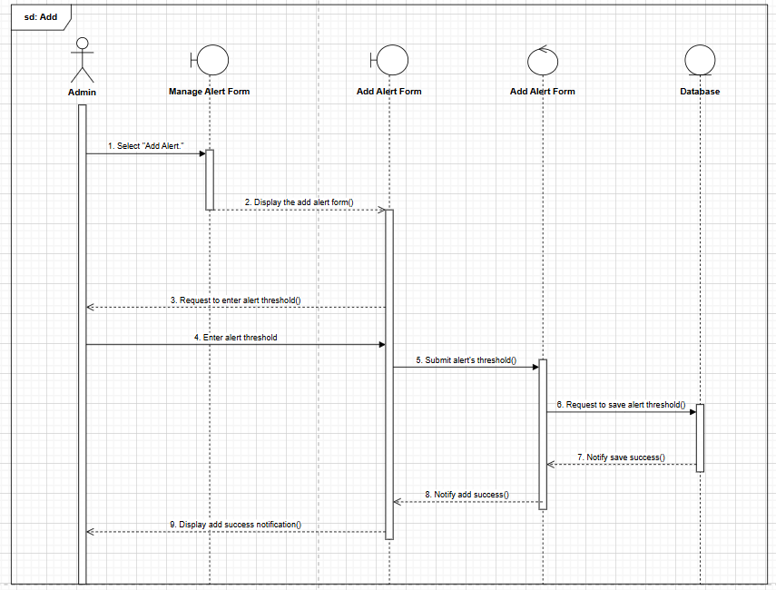

**2.5.17. (Admin) Delete Alert Threshold Sequence Diagram:**

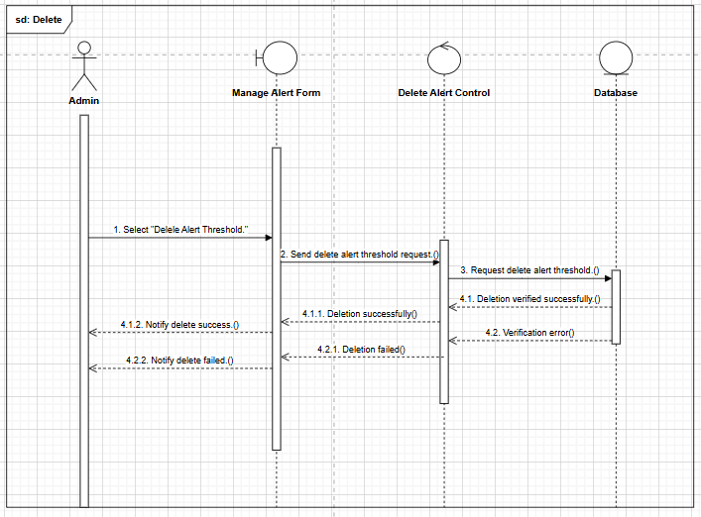

**2.5.18. (Admin) Manage user accounts Sequence Diagram:**

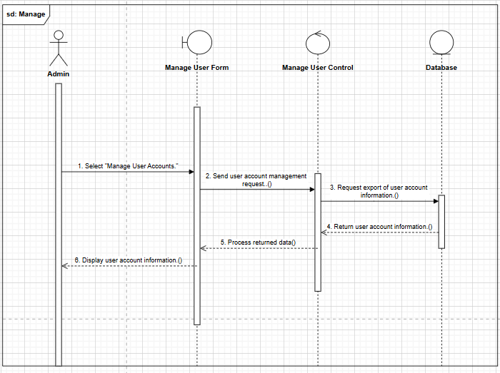

**2.5.19. (Admin) Add New Account Sequence Diagram:**

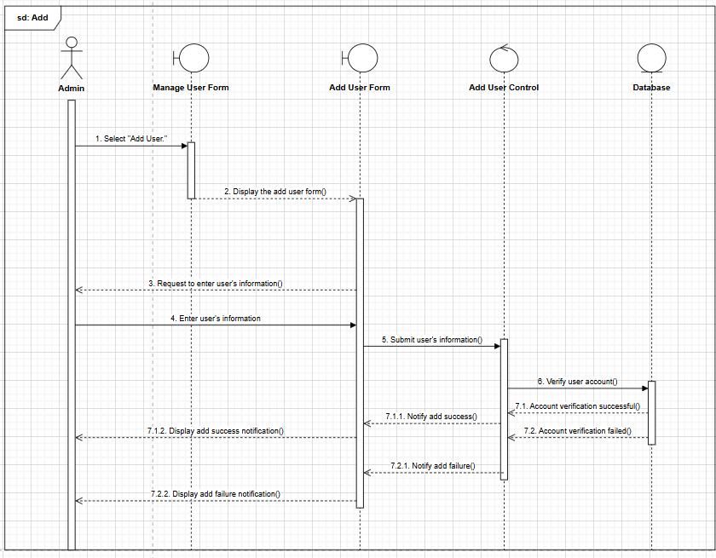

**2.5.20. (Admin) Edit Account Information Sequence Diagram:**

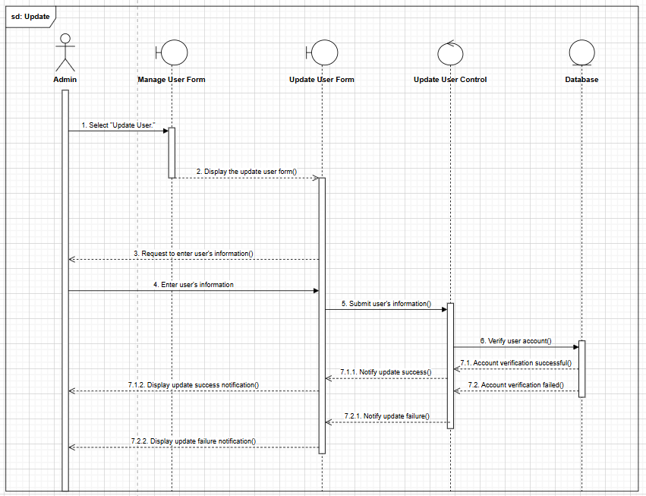

**2.5.21. (Admin) Delete Account Sequence Diagram:**

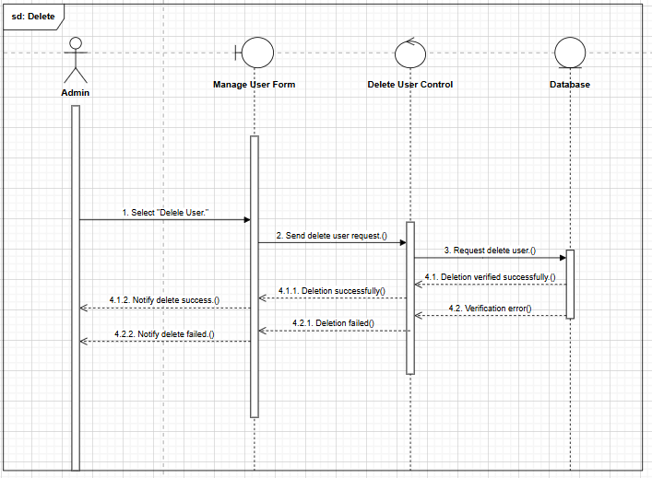

**2.5.22. (Admin) View air quality report Sequence Diagram:**

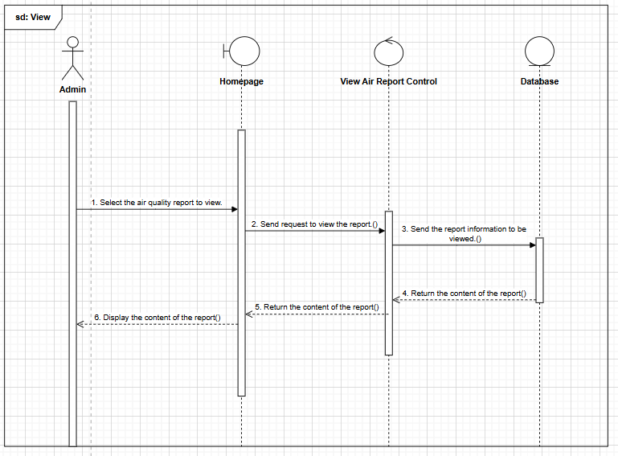

**2.5.23. (Admin) Statistic air quality report Sequence Diagram:**

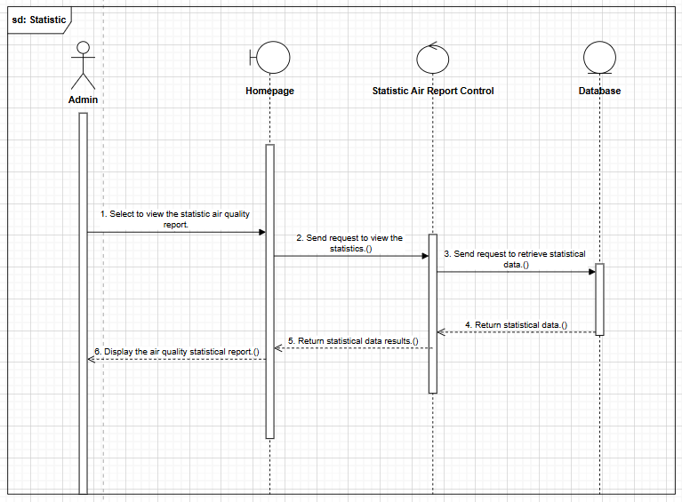

**2.5.24. (Sensor) Submit air quality data Sequence Diagram:**

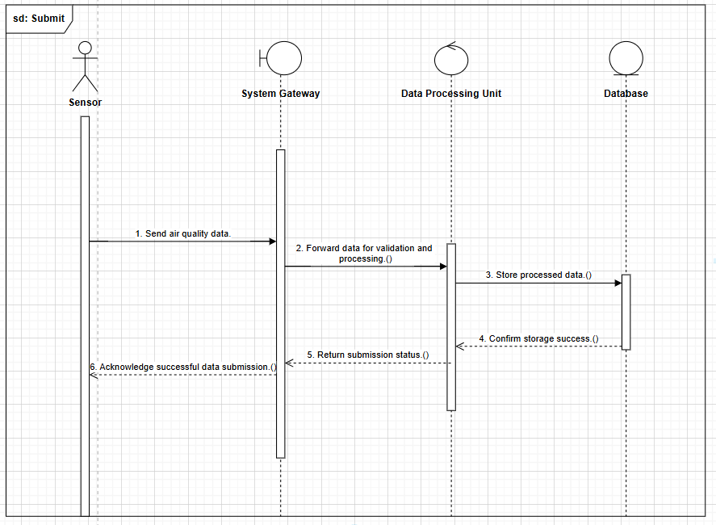

**2.6. ACTIVITY DIAGRAM:**

**2.6.1. (Guest) Register Activity Diagram:**

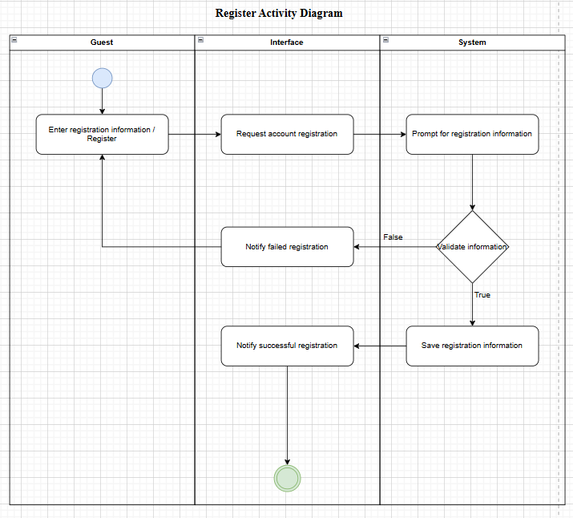

**2.6.2. (Guest) View air quality data Activity Diagram:**

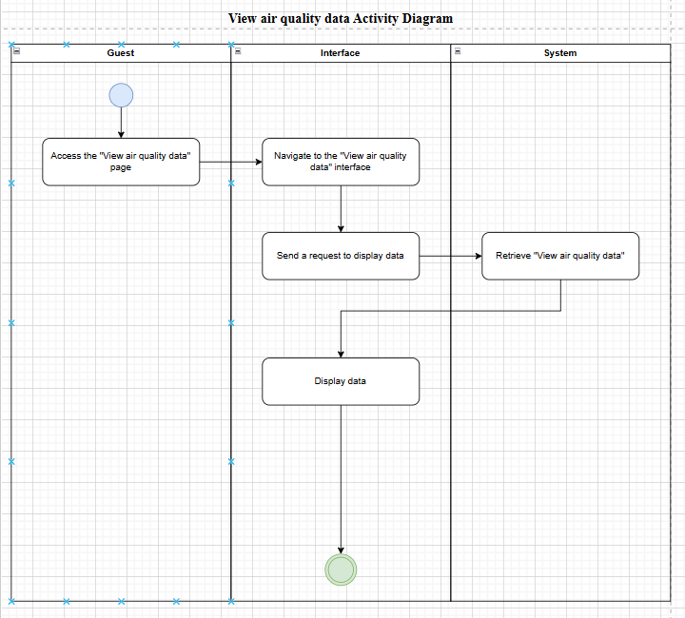

**2.6.3. (Guest) Search information by location Activity Diagram:**

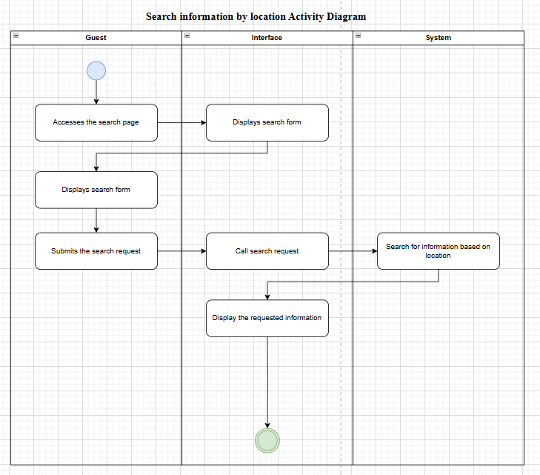

**2.6.4. (User) Log in Activity Diagram:**

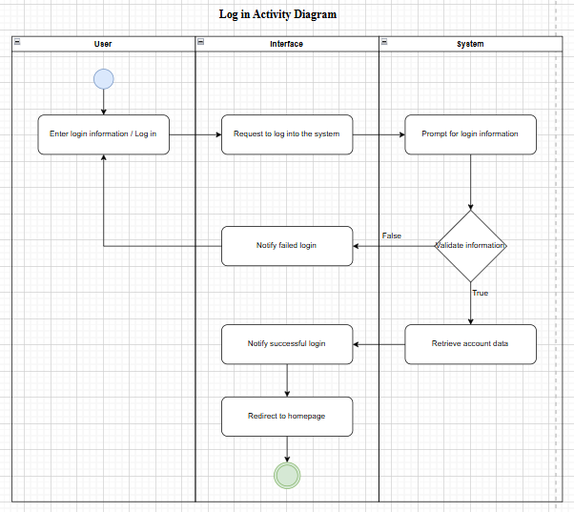

**2.6.5. (User) View detailed air quality data Activity Diagram:**

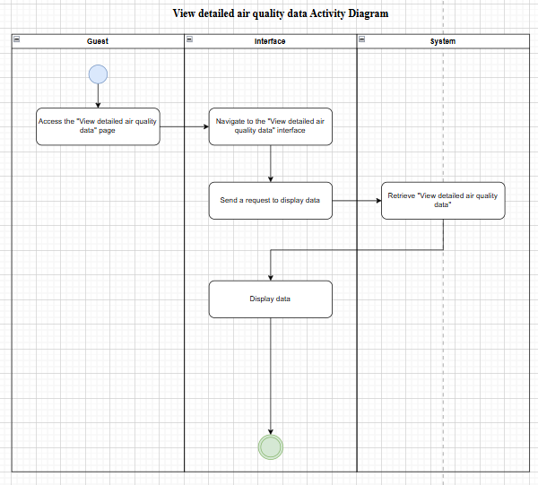

**2.6.6. (User) View air quality forecast Activity Diagram:**

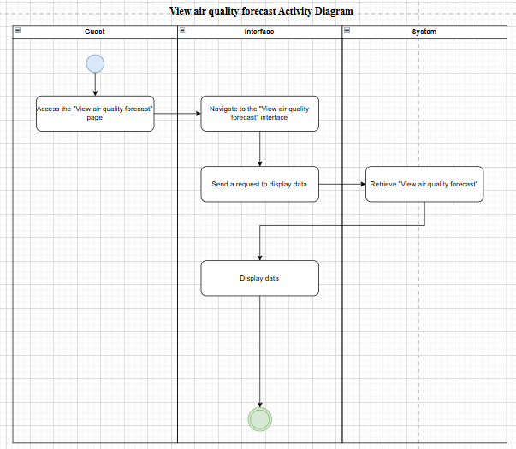

**2.6.7. (User/Admin) Forgot password Activity Diagram:**

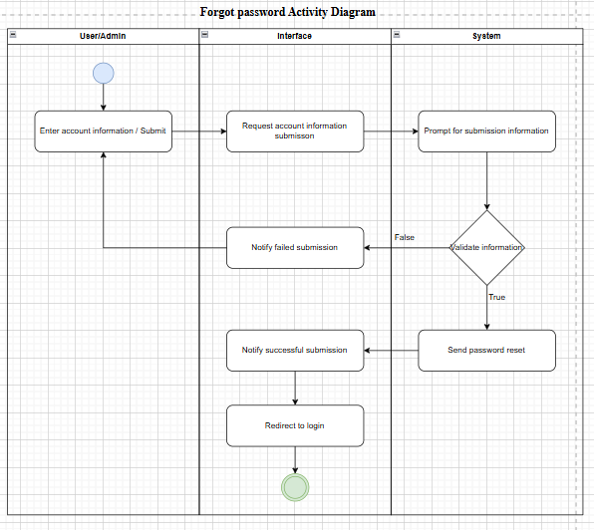

**2.6.8. (Admin) Log in Activity Diagram:**

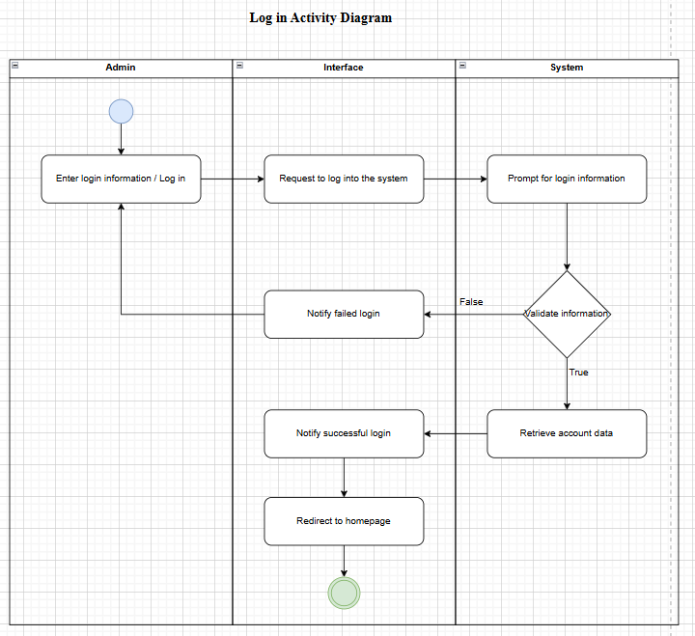

**2.6.9. (Admin) Update Sensor Data Activity Diagram:**

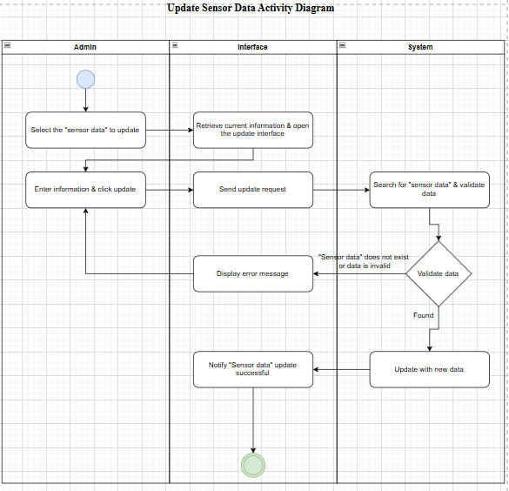

**2.6.10. (Admin) Delete Sensor Data Activity Diagram:**

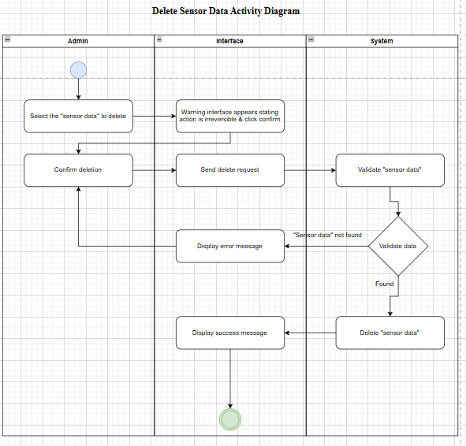

**2.6.11. (Admin) Add New Alert threshold Activity Diagram:**

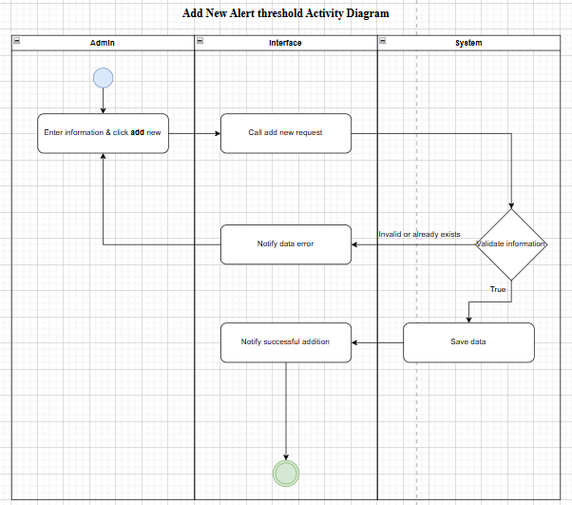

**2.6.12. (Admin) Delete Alert Threshold Activity Diagram:**

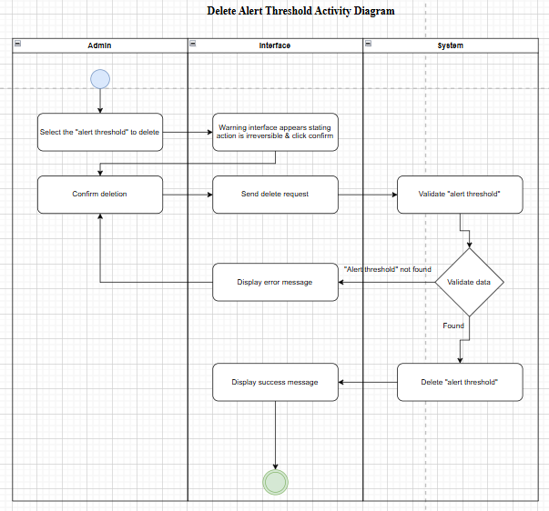

**2.6.13. (Admin) Add New Account Activity Diagram:**

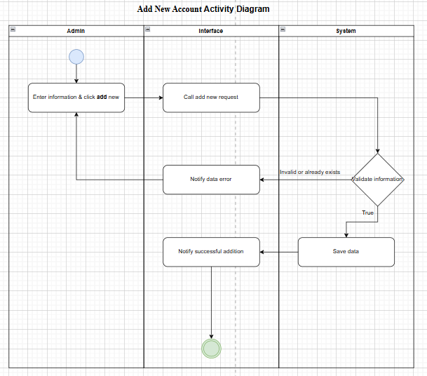

**2.6.14. (Admin) Edit Account Information Activity Diagram:**

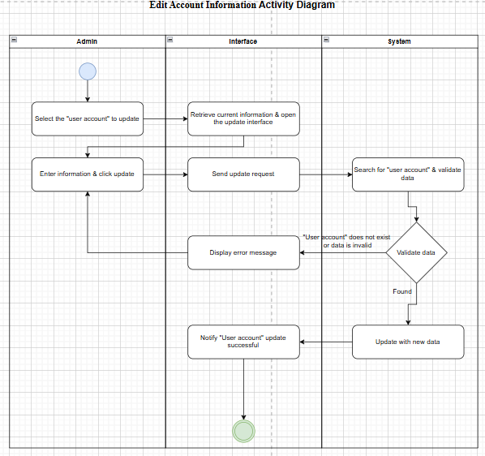

**2.6.15. (Admin) Delete Account Activity Diagram:**

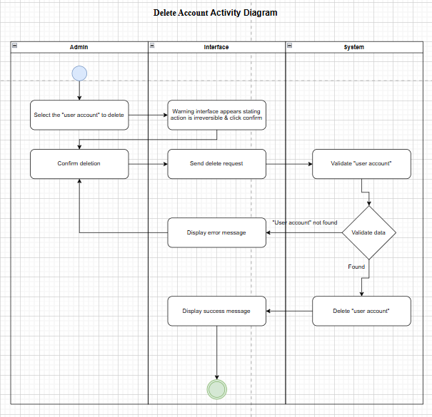

**2.6.16. (Admin) View air quality report Activity Diagram:**

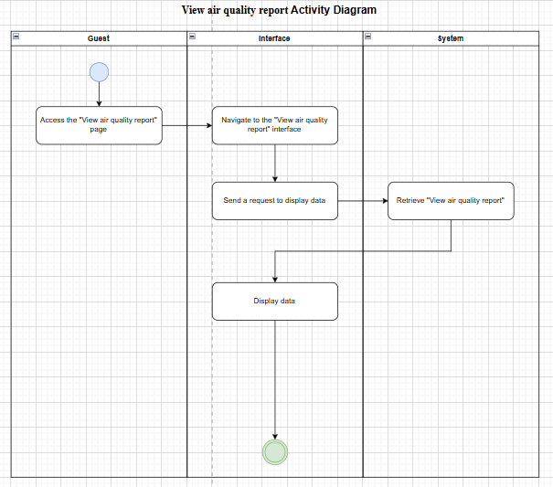

**2.6.17. (Admin) Statistic air quality report Activity Diagram:**

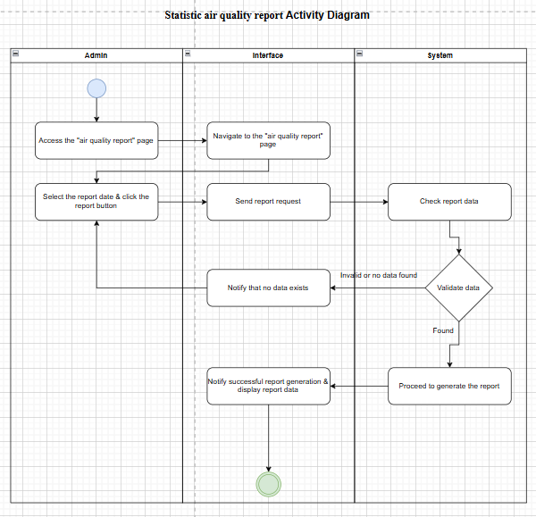

**2.7. CLASS DIAGRAM:**

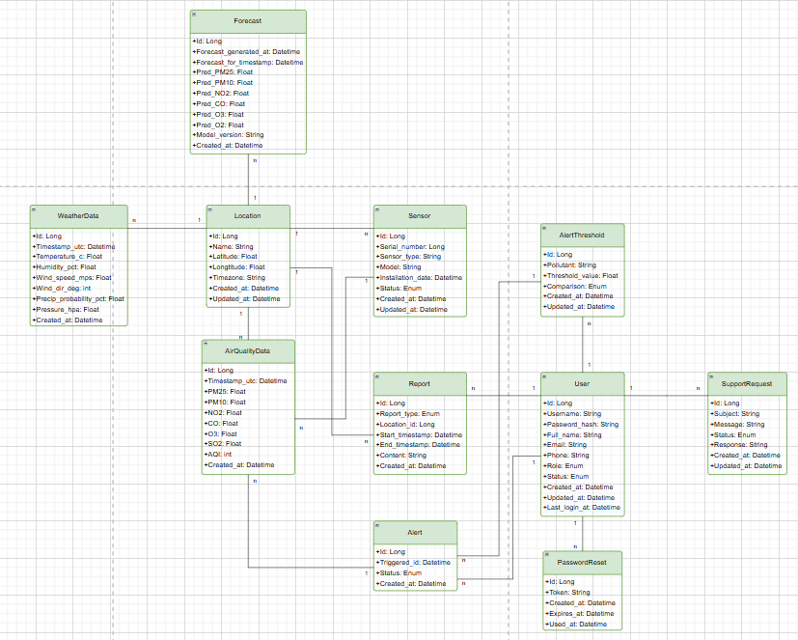**2.7.2. Database Relationship Diagram (DRD):**

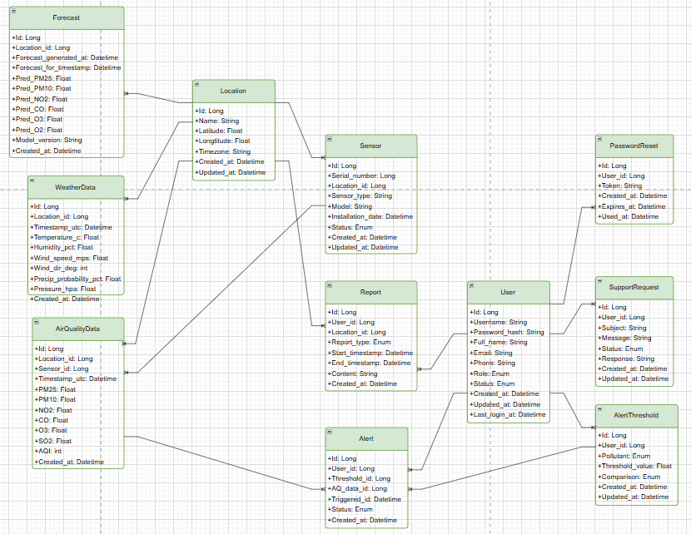

**2.8. DATABASE DESIGN:**

**2.8.1. Enhanced entity-relationship Model (EER):**

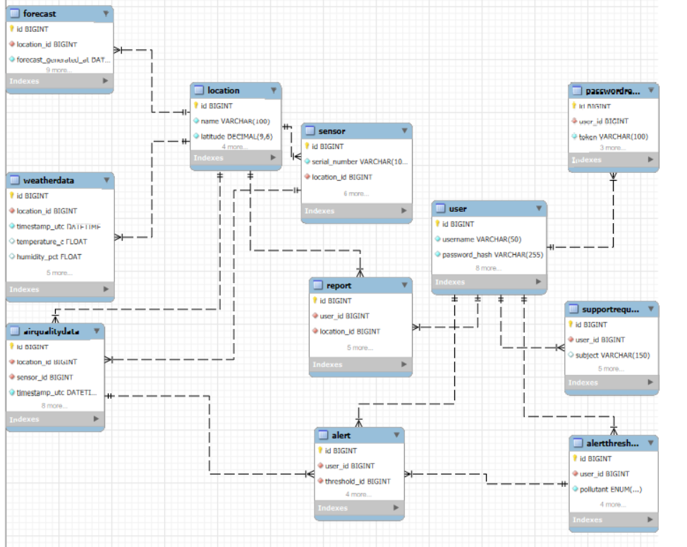

**2.8.2. Physical Model:**

* **Location**

|  |  |  |  |  |
| --- | --- | --- | --- | --- |
| **Column** | **Type** | **Null** | **Extra** | **Link to** |
| **id** | **bigint** | **No** | **auto_increment** |  |
| name | varchar(100) | No |  |  |
| latitude | decimal(9,6) | No |  |  |
| longtitude | decimal(9,6) | No |  |  |
| timezone | varchar(50) | No |  |  |
| created_at | datetime | No | default current_timestamp |  |
| update_at | datetime | No | default current_timestamp on update current_timestamp |  |

* **Sensor**

|  |  |  |  |  |
| --- | --- | --- | --- | --- |
| **Column** | **Type** | **Null** | **Extra** | **Link to** |
| **id** | **bigint** | **No** | **auto_increment** |  |
| serial_number | varchar(100) | No | unique |  |
| location_id | bigint | Yes |  | location.id |
| sensor_type | varchar(50) | No |  |  |
| model | varchar(100) | Yes |  |  |
| installation_date | date | Yes |  |  |
| status | enum | No | default active |  |
| created_at | datetime | No | default current_timestamp |  |
| updated_at | datetime | No | default current_timestamp on update current_timestamp |  |

* **AirQualityData**

|  |  |  |  |  |
| --- | --- | --- | --- | --- |
| **Column** | **Type** | **Null** | **Extra** | **Link to** |
| **id** | **bigint** | **No** | **auto_increment** |  |
| location_id | bigint | No |  | location.id |
| sensor_id | bigint | No |  | sensor.id |
| timestamp_utc | datetime | No |  |  |
| pm2.5 | float | Yes |  |  |
| pm10 | float | Yes |  |  |
| no2 | float | Yes |  |  |
| co | float | Yes |  |  |
| o3 | float | Yes |  |  |
| so2 | float | Yes |  |  |
| aqi | int | Yes |  |  |
| created_at | datetime | No | default current_timestamp |  |

* **WeatherData**

|  |  |  |  |  |
| --- | --- | --- | --- | --- |
| **Column** | **Type** | **Null** | **Extra** | **Link to** |
| **id** | **bigint** | **No** | **auto_increment** |  |
| location_id | bigint | No |  | location.id |
| timestamp_utc | datetime | No |  |  |
| temperature_c | float | Yes |  |  |
| humidity_pct | float | Yes |  |  |
| wind_speed_mps | float | Yes |  |  |
| wind_dir_deg | int | Yes |  |  |
| precip_probability_pct | float | Yes |  |  |
| pressure_hpa | float | Yes |  |  |
| created_at | datetime | No | default current_timestamp |  |

* **Forecast**

|  |  |  |  |  |
| --- | --- | --- | --- | --- |
| **Column** | **Type** | **Null** | **Extra** | **Link to** |
| **id** | **bigint** | **No** | **auto_increment** |  |
| location_id | bigint | No |  | location.id |
| forecast_generated_at | datetime | No |  |  |
| forecast_at_timestamp | datetime | No |  |  |
| pred_pm25 | float | Yes |  |  |
| pred_pm10 | float | Yes |  |  |
| pred_no2 | float | Yes |  |  |
| pred_co | float | Yes |  |  |
| pred_o3 | float | Yes |  |  |
| pred_so2 | float | Yes |  |  |
| model_version | varchar(50) | Yes |  |  |
| created_at | datetime | No | default current_timestamp |  |

* **User**

|  |  |  |  |  |
| --- | --- | --- | --- | --- |
| **Column** | **Type** | **Null** | **Extra** | **Link to** |
| **id** | **bigint** | **No** | **auto_increment** |  |
| username | varchar(50) | No | unique |  |
| password_hash | varchar(255) | No |  |  |
| full_name | varchar(100) | Yes |  |  |
| email | varchar(100) | No | unique |  |
| phone | varchar(20) | Yes |  |  |
| role | enum | No | default ‘user’ |  |
| status | enum | No | default ‘active’ |  |
| created_at | datetime | No | default current_timestamp |  |
| updated_at | datetime | No | default current_timestamp on update current_timestamp |  |
| last_login_at | datetime | Yes |  |  |

* **AlertThreshold**

|  |  |  |  |  |
| --- | --- | --- | --- | --- |
| **Column** | **Type** | **Null** | **Extra** | **Link to** |
| **id** | **bigint** | **No** | **auto_increment** |  |
| user_id | bigint | No |  | user.id |
| pollutant | enum | No |  |  |
| threshold_value | float | No |  |  |
| comparison | enum | No |  |  |
| created_at | datetime | No | default current_timestamp |  |
| updated_at | datetime | No | default current_timestamp on update current_timestamp |  |

* **Alert**

|  |  |  |  |  |
| --- | --- | --- | --- | --- |
| **Column** | **Type** | **Null** | **Extra** | **Link to** |
| **id** | **bigint** | **No** | **auto_increment** |  |
| user_id | bigint | No |  | user.id |
| threshold_id | bigint | No |  | threshold.id |
| aq_data_id | bigint | No |  | aq_data.id |
| triggered_at | datetime | No |  |  |
| status | enum | No | default ‘sent’ |  |
| created_at | datetime | No | default current_timestamp |  |

* **Report**

|  |  |  |  |  |
| --- | --- | --- | --- | --- |
| **Column** | **Type** | **Null** | **Extra** | **Link to** |
| **id** | **bigint** | **No** | **auto_increment** |  |
| user_id | bigint | No |  | user.id |
| location_id | bigint | No |  | location.id |
| report_type | enum | No |  |  |
| start_timestamp | datetime | Yes |  |  |
| end_timestamp | datetime | Yes |  |  |
| content | text | Yes |  |  |
| created_at | datetime | No | default current_timestamp |  |

* **SupportRequest**

|  |  |  |  |  |
| --- | --- | --- | --- | --- |
| **Column** | **Type** | **Null** | **Extra** | **Link to** |
| **id** | **bigint** | **No** | **auto_increment** |  |
| user_id | bigint | No |  | user.id |
| subject | varchar(150) | Yes |  |  |
| message | text | No |  |  |
| status | enum | No | default ‘open’ |  |
| response | text | Yes |  |  |
| created_at | datetime | No | default current_timestamp |  |
| updated_at | datetime | No | default current_timestamp on update current_timestamp |  |

* **PasswordReset**

|  |  |  |  |  |
| --- | --- | --- | --- | --- |
| **Column** | **Type** | **Null** | **Extra** | **Link to** |
| **id** | **bigint** | **No** | **auto_increment** |  |
| user_id | bigint | No |  | user.id |
| token | varchar(100) | No | unique |  |
| created_at | datetime | No | default current_timestamp |  |
| expires_at | datetime | No |  |  |
| used_at | datetime | Yes |  |  |

**PART 3**

**IMPLEMENTATION, DEPLOYMENT, AND TESTING OF SEVERAL CUSTOMER REQUIREMENTS**

**CONCLUSION**

**REFERENCES**

**Google Scholar document:**

1.<https://iopscience.iop.org/article/10.1088/1742-6596/2115/1/012016/pdf>

**Internet document:**

2.<https://www.kingston.ac.uk/about/news/affordable-ai-powered-air-pollution-sensors-can-revolutionise-monitoring-of-air-quality>

**ChatGPT document (World):**

3.<https://www.stateofglobalair.org/resources/report/state-global-air-report-2024>

4.<https://www.prnewswire.com/news-releases/2024-iqair-world-air-quality-report-finds-only-17-of-global-cities-meet-who-air-pollution-guideline-302397828.html>

5.<https://www.reuters.com/business/healthcare-pharmaceuticals/only-seven-countries-met-who-air-quality-standards-2024-data-shows-2025-03-11/>

6.[UNICEF Knowledge Hub+2State of Global Air+2IHME+2](https://www.stateofglobalair.org/resources/report/state-global-air-report-2024?utm_source=chatgpt.com)

7.[AP News+4Reuters+4Sigma Earth+4](https://www.reuters.com/business/healthcare-pharmaceuticals/only-seven-countries-met-who-air-quality-standards-2024-data-shows-2025-03-11/?utm_source=chatgpt.com)

8. [The Independent+2PR Newswire+2AP News+2](https://www.prnewswire.com/news-releases/2024-iqair-world-air-quality-report-finds-only-17-of-global-cities-meet-who-air-pollution-guideline-302397828.html?utm_source=chatgpt.com)

**ChatGPT document (Vietnam):**

9.<https://www.sciencedirect.com/science/article/pii/S1364815224003736>

10.<https://vietnamlawmagazine.vn/nation-to-install-more-automatic-air-quality-monitoring-stations-71413.html>

11.<https://en.baochinhphu.vn/master-plan-on-environmental-monitoring-issued-111240311112600695.htm>

12. <https://vietnamnews.vn/environment/1652451/viet-nam-s-air-quality-second-worst-in-asean-ha-noi-most-polluted-in-country-last-year-report.html>

**Related technology document:**

13. <https://docs.oracle.com/en/java/> (Java)

14. <https://docs.spring.io/spring-boot/index.html> (Spring boot)

15. <https://maven.apache.org/guides/index.html> (Maven - Apache Maven)

16. <https://dev.mysql.com/doc/workbench/en/> (MySQL Workbench - MySQL)

17. <https://react.dev/> (ReactJS)

18. <https://docs.aws.amazon.com/iot/> (IoT – Amazon)

19. <https://docs.iotcreators.com/docs/everything-you-want-to-know-about-mobile-iot> (IoT - iotcreators.com)

20. <https://cloud.google.com/document-ai> (AI - Google Cloud)